It is helpful to use devices like cell phones and computers when you prepare for an emergency and during an emergency. You can use cell phones and computers to store information, share information, and get help when needed. If you use them, include them in your Personal Emergency Plan.
Some cell phones are called smartphones because they let you do many things besides just making a phone call. You can write messages, which is called texting. You can send emails just like you do now on your computer.
Smartphones have Apps (short for Applications) on them. Apps are programs that let you do many things by just touching them. For example, Apps can remind you to take your medicine or buy emergency supplies.
Apps are also on a type of computer called a tablet. A tablet is smaller than a laptop computer so it is easier to carry with you. You touch the screen to use it.

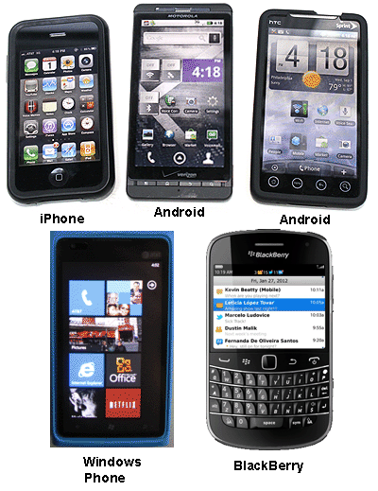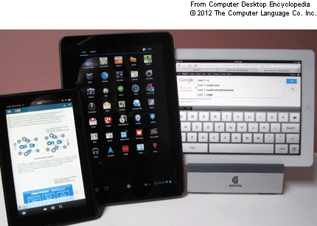
Smartphones Tablets

Storing and Sharing Information
You can keep your medical records, contacts, and other forms from your Personal Emergency Plan on your computer and on a flash drive that you can carry with you.
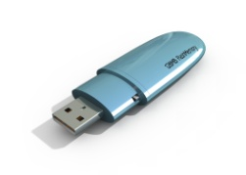
Flash Drive
You can also store information on your computer so that it can be shared with other people on any computer. This is called the cloud. Programs like Google Docs let you fill out and save forms that other people can see.
Some Apps let you store information on your phone or tablet. For example, the Red Cross and FEMA have Apps that let you put in the names of your contacts and where you will go in case of an emergency. StopDisaster shows you what supplies you need and helps you make a shopping list. There are many Apps that let you store emergency information. You can search App stores such as iTunes or Google Store for Apps that will be the most helpful to you. Many are free or cost very little.
Getting Help
During an emergency it is very important to get the correct information about what is happening. You need to know if you must leave your home. How will you reach your contacts? What if you are not able to leave on your own and need help?
You can receive information on emergencies by signing up for any registry or alert systems that are available in your area. These can be through your local town, city, or county or through a state system such as NY-Alert. They can let you know that there is an emergency by phone, text, or email. Some even have Apps that you can put on your phone or tablet.
To call for help you can use a land line phone and a cell phone. But sometimes these are not working. During recent storms many people were able to reach out for help by texting on their phones, sending emails, or on Facebook. You may want to learn how to connect with friends, family, and other support people by using Facebook or Twitter.

There are many Apps that will help you reach contacts, call 911, locate shelters if needed, let others know you are safe, and other activities in an emergency. Along with the FEMA and Red Cross App, a good one is called Disaster Prep. It not only lets you store information but it guides you during the emergency.
Using devices can be confusing. Ask your support persons to help you learn how to text or use email. Ask them to explain what an App is and how to put one on your phone or tablet. Remember to keep your devices charged and close by!
There are many ways to reach others in an emergency. Learn to use more than one when you put together your Personal Emergency Plan.

