My Safety  
My Responsibility   
My Plan

**A training program on emergency preparedness**

**Marilyn Vitale**

**Westchester Institute for Human Development**

**Developed through corporate funding from Entergy and with the support of the Westchester County Department of Emergency Services and the American Red Cross in Westchester County**

****Copyright © 2009

**Preface**

**My Safety, My Responsibility, My Plan** is a multi-session program to train adults with intellectual disabilities to understand and to be prepared for emergencies. The program includes information and discussion, hands-on activities, and between-session tasks. The step-by-step approach and follow-up at each session ensure that tasks are completed.

The program begins with information on various emergency situations with details on what to do in different scenarios. The material is written in understandable language with important words and concepts clearly defined.

Each session involves activities that encourage the participants to think about all the factors that will be pertinent during an emergency including:

* Where they might be
* Who will help them
* What their personal needs are in the areas of medical, mobility, daily living, and communication
* How they might feel and behave
* What items, information, and documents they need

Participants are given tasks to complete between sessions such as gathering information and documents, contacting public officials, getting supplies, and speaking to support people. There is a ***Things To Do*** checklist that they can use to keep track of their tasks.

All of the information gathered from the worksheets, community tasks, and other activities are transferred to the appropriate forms in their ***Personal Emergency Plan***. This plan is placed in a folder along with copies of documents, and the folder is kept in their Go-bag.

At the end of the program each participant will have a curriculum with vital reference information, a ***Personal Emergency Plan*** suited to their individual needs, and a **Go-Bag** with supplies as well as the basic supplies to keep in their homes.

The program was developed for group training, but it can be adapted for use on an individual basis or for persons who need more support.

Individuals who live on their own or with some support can maintain their own plans. However, those who live with their family or others must also be a part of a ***Family Emergency Plan***. The supplemental ***Family Guide on Emergency Preparedness*** instructs families on what they need to know, do, and obtain in order to develop their plan.

All information is based on the principles set by FEMA, the Department of Homeland Security, the American Red Cross and the U.S. Fire Administration. Specific documents and references are listed in the **References and Resources** section. **Table of Contents**

**Page**

**Introduction** ……………………………………………………………………….................1

**Section 1**: **What You Need To Know to Be Safe** …………………………….....2

What is an emergency? ………………………………………………………………………..3

Can it happen here? ................................................................................4

*Things to Remember*……………………………………………………………………….......9

**Section 2**: **What You Need to Know About Yourself** ……………………....10

*My Personal Needs* …………………………………………………………………..……11-23

*My Health Summary Sample……………………………………………………………….*24

**Section 3: Your Support People** ……………………………………………………….25

*My Routine Activities* ………………………………………………………………………27-28

*Contact List* …………………………………………………………………………………………29

*Things to Remember* ..............................................................................30

**Section 4: What You Need to Plan to Be Safe** ....................................31

*Steps in an Emergency Sample* ..............................................................35

*Things to Remember*…………………………………………………………………...........36

**Section 5**: **What You Need to Have in an Emergency**.........................37 What supplies do you need? ……………………………………………………...........38 *Basic Supplies Home Kit Checklist*...........................................................39

What is a Go-bag? ……………………………………………………………………..........40 *Go-bag Checklist* ……………………………………………………………………….........42 *Things to Remember* .............................................................................43

**Section 6: Fire Safety** ……………………………………………………………….........44

*Escape Plan Sample* …………………………………………………………………..........46

*Things to Remember* …………………………………………………………………..........48

**Section 7**: **Review of What You Learned**…………………………………………..49

*Things to Review*………………………………………………………………………...........53

*Things to Do*………………………………………………………………………………........54

**References and Resources** ………………………………………………………....55-57

***Personal Emergency Plan Sample***

**Introduction**

**What will you learn from this program?**

During this training program you will learn about types of emergencies, what you should do in an emergency, and what you need to get for supply kits. You will put together a ***Personal Emergency Plan*** that includes information and documents that you need to have in an emergency. As you go through this program you will complete the forms from the ***Personal Emergency Plan***. Look for the arrow **BD21298_** to find out which form to use at the end of a section.

Some of the things you will do during this training are:

* Talk about what happens during emergencies
* Think about your individual needs
* Think about who are your support people
* Plan with your support people about how you will hear about emergencies, how you will reach them, and your transportation needs
* Discuss what to do if you must leave your home
* Know what to do if you cannot leave your home
* Write down your plan
* Put together emergency supply kits
* Learn about Fire Safety
* Make your own ***Personal Emergency Plan***

Each of these areas will be covered throughout this program. The activities and checklists will help you understand what you need to do during the training and at home and in your community. Wherever there is a check like this **MCj04347130000[1]**youwill find tasks you need to do or things you need to discuss with your support people.

At the beginning of each section, you will see a list of **Things we’ll do...** There is also a list of what you will learn under **After this section I will…** and a list of what you need to do at home or in the community under **After this section I need to…** At the end of the program, there is a full list of all you need to do called ***Things to Do***. You can check it to make sure you have done everything.Remember, it is your **Responsibility** to be prepared, have a **Plan**, and be **Safe**.

**Section 1: What You Need To Know To Be Safe**

**Things we’ll do**

* Discuss what it means to be prepared
* Find out what types of emergencies might happen in my community

**After this section I will**

* Understand why I must prepare for an emergency
* Know what I must do in different types of emergencies
* Understand these words:
* Emergency
* First responder
* Evacuate
* Shelter-in-place
* Hazard

**MCj04347130000[1]After this section I need to**

* Contact utilities company if needed
* Learn how to shut off utilities

**What is an emergency?**

When you wake up in the morning you have a routine. You get washed, dressed, eat breakfast, and go out into the community. You think about what to wear, what to eat, and where you have to go. You have plans for the day and you usually have a good idea of what will happen during the day. Sometimes, however, something that is not planned can happen. For example, bad weather can make it hard to get to where you want to go. Usually you can make another plan for the day. But what if something happens that is more serious, something that is an emergency? **Emergency** means that you must do something right away in order to be safe.

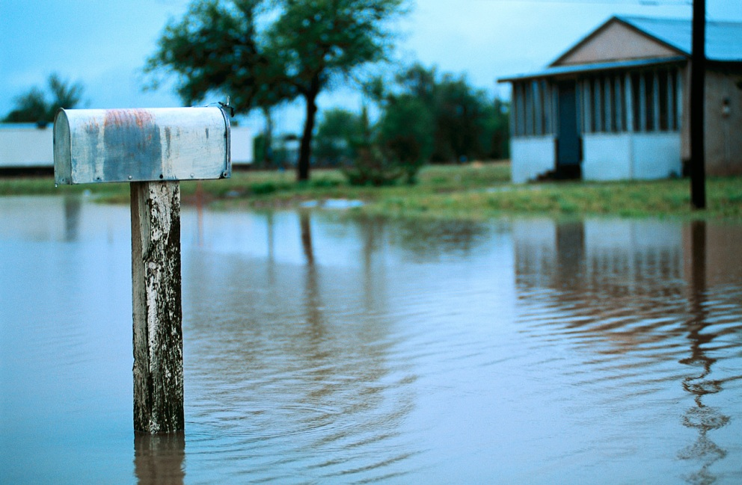

Some of the emergency situations that could happen are:

* Winter storm
* Thunderstorm
* Hurricane, Tornado
* Flood
* Heat Wave
* Loss of electricity
* Fire

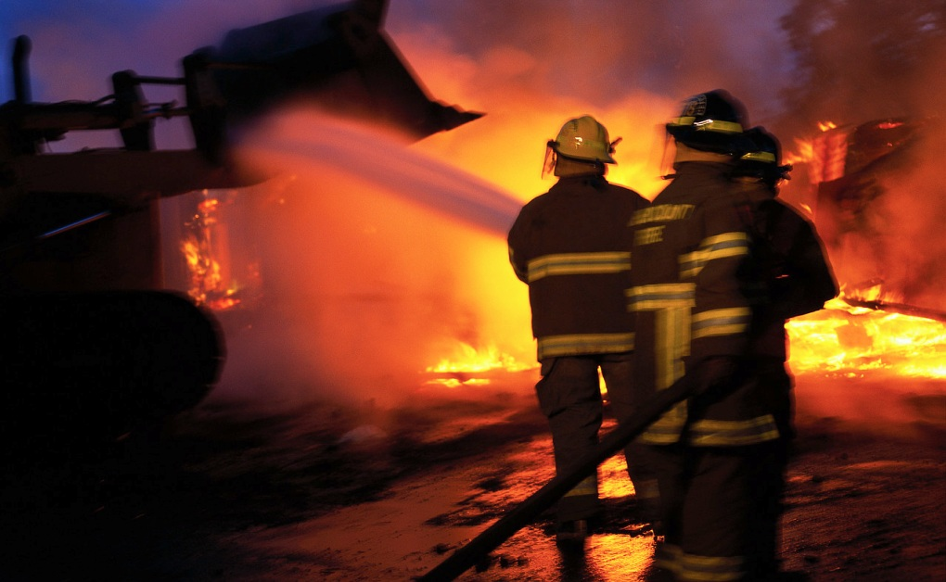

In some of these emergencies, you might have to **evacuate**, which means to leave your home. If so, you would have to know who to call, where to go, and what to bring with you. Someone may be there to help you, like a fire person or medical technician. These are called **first responders**. They need to know about you. In other cases, it might be safer to stay in your home. This is called **shelter-in-place**. You would need to know what to do, who to call, and what supplies to keep in your home.

**Can it happen here?**

**Hazards** are events or situations that are dangerous and cause emergency situations. They are often related to the weather. In the Northeast part of the United States the most common weather conditions that cause emergencies are heavy rains, thunderstorms and lightning, snow storms, extreme cold, and heat waves. Hurricanes can happen, and once in awhile there is a tornado. Sometimes an earthquake happens in the Northeast.

**Winter storms** can be either freezing rain, sleet, snow, or a blizzard. **Sleet** means that rain turns to ice pellets before reaching the ground and can be very slippery. A **blizzard** means that there is a lot of snow along with strong winds. You may hear that there is a **Winter Storm Watch**. That means a storm might happen. A **Winter Storm Warning** means that the storm is on the way. You should be prepared to stay inside during a storm. It is dangerous to be out on slippery roads. Very cold air can be harmful to your body. If you are outside in the cold, make sure you cover your hands, head, and your mouth to protect your lungs from the cold.

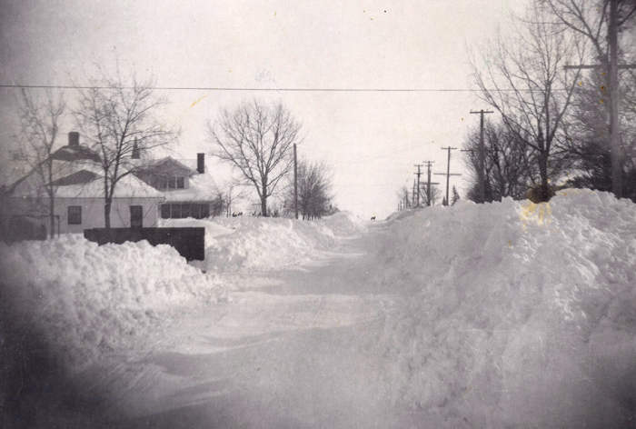

**Thunderstorms and lightning** can occur at any time during the year and can be dangerous. They cause heavy rain and sometimes hail. Lightning can strike objects, especially outside in an open area. You must get inside as quickly as possible. Close your windows, blinds, shades, and curtains. During the storm do not take a shower and try not to use a telephone with a cord as these can conduct electrical charge from the storm. Bring in any outdoor objects that can blow away or get broken during a storm. It is a good idea to unplug appliances and electrical items like televisions and computers as they can be damaged during a lightning storm.

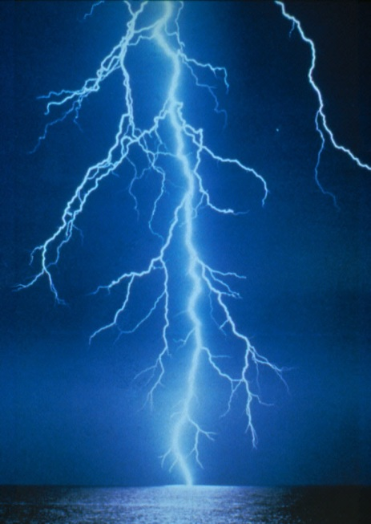

**Hurricanes** are severe storms that have heavy rain and very strong winds and heavy ocean waves. Hurricanes can cause damage to buildings, trees, and anything that is outside. Before a hurricane hits, you may be told to leave your home. However, if you remain in your home during the hurricane, it is important to stay away from windows and glass doors. Keep the blinds or curtains closed. Do not go outside. Something like a falling tree could hit you.

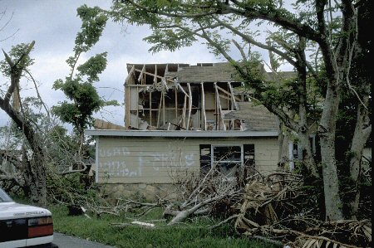

**Tornadoes** are violent storms that look like a cone and carry very high winds. They are so dangerous that you must go inside immediately and stay in a place without windows like a bathroom or basement. If you do not have a basement, go to an inside room, closet, or hallway on the first level of your home. Tornadoes can happen in the Northeast but not very often. You might hear of a Tornado Warning on the radio or television.

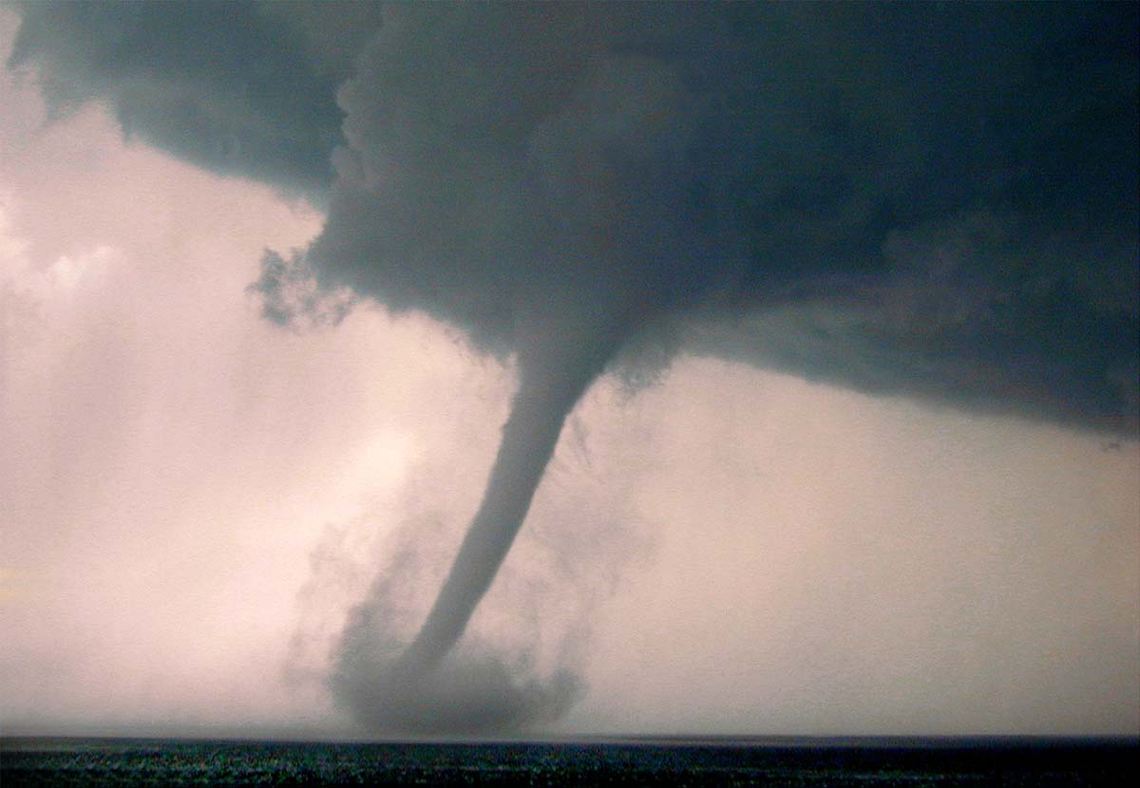

**Earthquakes** can happen once in awhile in the Northeast. If you feel the ground shaking or some things moving in your home, this could be an earthquake. You must get to the floor if possible, get under something for cover, and hold on during the shaking. Get away from any objects that could fall on you. Earthquakes are very quick, most times less than a minute.

**Floods** are common hazards. Theycan happen from heavy rains and melting snow. Rivers can overflow causing floods on the roads and in your home. You may hear on the radio that there is a **Flood Watch** or **Flashflood Watch**. That means flooding could happen. A **Flood Warning** or **Flashflood Warning** is more serious. It may mean that you have to leave the area. It is important not to walk through the water since there may be dangerous materials or electrical charges in it. Fast moving water can also knock you down. Make sure you stay away from any power lines that have fallen down.

In the summer a **heat wave** can also be dangerous. When the temperature is very high, it is better to stay indoors and out of the sun. Go to an air-conditioned place. Drink lots of water. Wear light clothing. Do not plan outside activities until the temperature has gone down.



**Blackouts**, or the loss of electricity, can occur during heat waves when many people are using air-conditioners. All types of storms can also cause electricity, heat, or telephone power to go out. In some cases you may have to stay in your home until the power comes on. You will need your supplies such as a flashlight to keep you safe. If you use any equipment that runs on electricity, you must plan on what you will do in a blackout. **MCj04347130000[1]**It is a good idea to let the utilities company know that you need electricity for your equipment. In case of a blackout, they will try to get your electricity back on quickly. However, that is not always possible so you may have to use back-up batteries or a generator. If the power is going to be off for a long time, you may have to leave your home. Then you will need to take your emergency kit with you.

There can be emergencies that are not related to the weather. These include **chemical, biological**, or **nuclear accidents** as well as **construction accidents** that might happen in your neighborhood. They could possibly be dangerous situations. You may have to evacuate your home. In these situations, emergency people will tell you what you need to do. If you live in your own home, you may have to turn off utilities like electricity, gas, or water, heat or air conditioning. **MCj04347130000[1]**Have a support person show you where these are located and how to shut them. But remember: do not turn the gas back on by yourself! This must be done by a professional. **Fires** are emergency situations that are very dangerous. It is important to know what to do to prevent fires and what to do in case of a fire. This is covered in **Section 6:** **Fire Safety**.

***Things to Remember***

* **Emergency** means that you must do something right away in order to be safe.
* In some emergencies, you might have to **evacuate**, which means to leave your home.
* **First responders** are people who help you in an emergency like police officers, firefighters, or medical technicians.
* In some emergencies it might be safer to stay in your home. This is called **shelter-in-place**.
* **Hazards** are events or situations that are dangerous and cause emergency situations.
* Some **hazards** are related to the weather like winter storms, thunderstorms and lightning, hurricanes, tornadoes, earthquakes, floods, heat waves, and blackouts. Some of these happen more often than others, depending on where you live.
* It is important to **review** and **remember** what you must do and not do during each of these emergencies.
* **Fire** is a hazard that can happen anywhere, at any time, and can be very dangerous. It is very important to know how to escape quickly in case of a fire.
* **Emergencies** can also include chemical, biological, or nuclear accidents or spills that can be dangerous. Public officials will tell you whether you must stay indoors or evacuate.
* Other **dangers** in your neighborhood like construction accidents may cause you to have to evacuate.
* It is necessary to have a ***Personal Emergency Plan***so that you know what to do, who to contact, what supplies and documents to have, and what special needs to tell others about in an emergency.

**Section 2: What You Need to Know About Yourself**

**Things we’ll do**

* Talk about different things people need in their daily life
* Learn what information is needed in an emergency
* Complete **My Personal Needs**

**After this section I will**

* Understand that each person has different needs
* See how my personal needs will fit into my emergency plan

**MCj04347130000[1]After this section I need to**

* Get information on medical history, immunizations, and medications
* Get information on any medical devices, communication devices, daily living devices, mobility devices or special vehicles that I use
* Discuss how I might feel during an emergency with my family, friends or support persons
* Complete the **Medical History,** **Immunizations**, **Medications, Daily Living/Mobility Needs, Communication/Emotional Needs** sections of my ***Personal Emergency Plan***
* Complete **My Health Summary**
* Get photo ID

**My Personal Needs**

Emergency situations can be very scary! That is why it is so important to prepare ahead of time. Now that you know what can happen, you must think about what you will need to have and what you will need to do in an emergency. Each of you has different needs. For example, one of you may need to wear eyeglasses and another of you may need to use a walker. Some of you may have a cell phone and some may not. This type of information is important when you are preparing for an emergency. ***My***

***Personal Needs*** is a form to help you to understand your needs. You can then use this information to make an emergency plan and to decide what supplies you need. Your plan will include your contact information, your medical information, your fire escape plan, your communication needs, evacuation plans, and any special needs. During this training you will gather this information and then organize it into your ***Personal Emergency Plan***.

The next pages contain the form ***My Personal Needs***. It is divided into the following sections:

* Medical Information
* Immunizations
* Medications
* Daily Living/Mobility Needs
* Communication/Emotional Needs

After you answer the questions in all of the areas, you will put the information in your ***Personal Emergency Plan***. It is divided into the same sections. You may not need to use all of the sections. For example, you may not need any help in the daily living or mobility area so you would not put anything in those boxes on your plan. Remember your ***Personal Emergency Plan*** is about **your** needs. Any support person or first responder should be able to look at it and know how to help you.

***My Personal Needs***

This form will help you to understand what information you need for your ***Personal Emergency Plan***. Answer the questions and fill in the boxes.This is your worksheet. At the end of each section of this form, it will tell you where to write the information in your ***Personal* *Emergency Plan***. Whenever you see a check **MCj04347130000[1]**you must get the information from your records or discuss your needs with your support person.

**Medical Information**

It is important to have up-to-date medical information. Complete as much as you can below. **MCj04347130000[1]** Check your records or ask your support person to help you get any other information you need.

Example:

**Primary Physician:** Dr. Michael Brown **Phone Number:** 914-777-7777**Fax:** 914-777-7722

**Address:** 12 Main St., Yonkers, NY 10332

**Medicaid Number:** DR12345M

**Medicare Number:** 1234567A

**Private Insurance:** Aetna **Policy Number:** 345678JKL

**Hospital:** Westchester Medical Center, Valhalla, NY

**Pharmacy:** Health Pharmacy, **Phone Number:** 914-888-8888 **Fax:** 914-888-8866

**Address:** White Plains, NY

**Blood Type:** B positive

**Primary Physician:** **Phone Number:** **Fax:**

**Address:**

**Medicaid Number:**

**Medicare Number:**

**Private Insurance:** **Policy Number:**

**Hospital:**

**Pharmacy:** **Phone Number:**  **Fax:**

**Address:**

**Blood Type:**

Think about any medical conditions you may have. These might include things like diabetes, asthma, high or low blood pressure, heart problems, and others. If you have regular medical treatments or routines, write them down. If you go to a special place for medical treatments, include the name of the place. Let the health care provider know if you are afraid of needles. See the following example.

Example:

**Medical Conditions:** Diabetes, Asthma, Arthritis in knee

**Regular Medical Treatments:**

Check blood sugar level daily, Use nebulizer when wheezing, physical therapy exercises for knee 3 times a week at Wellness Clinic, White Plains, NY

**Check if you are afraid of Needles** \_\_\_\_\_X\_\_\_\_

**Medical Conditions:**

**Regular Medical Treatments:**

**Check if you are afraid of Needles \_\_\_\_\_\_\_\_\_**

Do you have any allergies or sensitivities? If so, name the type of allergy and what happens to you if you have an allergic reaction. Include any special diet you may need.

Example:

**Allergies and Sensitivities/Reactions:**

Milk and dairy products, makes me wheeze

**Special Diet:** No dairy foods

**Allergies and Sensitivities:**

**Special Diet:**

Check off any of the following medical devices that you use.

Respirator \_\_\_ Nebulizer \_\_\_

Catheter \_\_\_ Tubing \_\_\_

Feeding tube \_\_\_

Oxygen \_\_\_ Suction unit \_\_\_

Glucometer \_\_\_ Insulin device \_\_\_

Home dialysis \_\_\_

Inhalator \_\_\_

Other medical supplies \_\_\_\_

**MCj04347130000[1]** Find out the name of the place where you get it (vendor), the vendor’s phone number, and whether or not it needs batteries or uses electricity. Name someone who knows how to work the device.

Example:

**Medical Devices Needed:**

**Type Vendor/Contact Phone Number Batteries? Electricity?**

Glucometer & Strips ABCDiabetes 212-555-2222 No No

**Type Vendor/Contact Phone Number Batteries? Electricity?**  Nebulizer MedEquip 212-333-2232 No Yes

**People who know how to work device:** Mary Jones and John Smith

\_\_\_\_\_\_\_\_\_\_\_\_\_\_\_\_\_\_\_\_\_\_\_\_\_\_\_\_\_\_\_\_\_\_\_\_\_\_\_\_\_\_\_\_\_\_\_\_\_\_\_\_\_\_\_\_\_\_\_\_\_\_\_ \_\_\_\_\_\_\_\_\_\_\_\_\_\_\_\_\_\_\_\_\_\_\_\_\_\_\_\_\_\_\_\_\_\_\_\_\_\_\_\_\_\_\_\_\_\_\_\_\_\_\_\_\_\_\_\_\_\_\_\_\_\_\_\_\_\_\_\_\_\_\_\_\_\_\_\_\_\_\_\_

**Medical Devices Needed:**

**Type Vendor/Contact Phone Number Batteries? Electricity?**

**Type Vendor/Contact Phone Number Batteries? Electricity?**

**People who know how to work device: \_\_\_\_\_\_\_\_\_\_\_\_\_\_\_\_\_\_\_\_\_\_\_\_\_\_\_\_\_\_\_\_\_\_\_\_\_** \_\_\_\_\_\_\_\_\_\_\_\_\_\_\_\_\_\_\_\_\_\_\_\_\_\_\_\_\_\_\_\_\_\_\_\_\_\_\_\_\_\_\_\_\_\_\_\_\_\_

* **Go to Form A of *Personal Emergency Plan* BD21298_**

**Immunizations**

First write down all of the most recent immunizations (shots) you have had. **MCj04347130000[1]** Then check your records for those you had in the past and write them down.

Example:

**Type Dates**

**Recent:**

PPD (Mantoux) 4/10/06, 4/24/07, 4/13/08 Negative

Influenza 10/09/06, 11/02/07, 10/23/08

Tetanus, Diphtheria (TD) 10/30/91, 6/10/01; 6/23/08 (T-Dap)

**Past:**

DTP 8/31/78, 10/20/78, 11/24/78, 1/12/78, 8/24/83

OPV 8/31/78, 10/20/78, 11/24/78 1/12/79, 8/24/83

Measles Mumps Rubella (MMR) 10/13/79, 10/17/91:

Tine 4/8/80, 12/3/80, 1/20/82, 12/83, 11/8/91 Negative.

Hepatitis B. 6/2/93, 8/9/93, 12/16/93. Blood test on 1/27/97 shows immunity

*Thi****SAMPLE***

**Type Dates**

**Recent\_\_\_\_\_\_\_\_\_\_\_\_\_\_\_\_\_\_\_\_\_\_\_\_\_\_\_\_\_\_\_\_\_\_\_\_\_\_\_\_\_\_\_\_\_\_\_\_\_\_\_\_\_\_\_\_\_\_\_\_\_\_\_\_\_\_\_\_\_\_\_\_\_\_\_\_\_\_\_\_\_\_\_\_\_\_\_\_\_\_\_\_\_\_\_\_\_\_\_\_\_\_\_\_\_\_\_\_\_\_\_\_\_\_\_\_\_\_\_\_\_\_\_\_\_\_\_\_\_\_\_\_\_\_\_\_\_\_\_\_\_\_\_\_\_\_\_\_\_\_\_\_\_\_\_\_\_\_\_\_\_\_\_\_\_\_\_\_\_\_\_\_\_\_\_\_\_\_\_\_\_\_\_\_\_\_\_\_\_\_\_\_\_\_\_\_\_\_\_\_\_\_\_\_\_\_\_\_\_\_\_\_\_\_\_\_\_\_\_\_\_\_\_\_\_\_\_\_\_\_\_\_\_\_\_\_\_\_\_\_\_\_\_\_\_\_\_\_\_\_\_\_\_\_\_\_\_\_\_\_\_\_\_\_\_\_\_\_\_\_\_\_\_\_\_\_\_\_\_\_\_\_\_\_\_\_\_\_\_\_\_\_\_\_\_\_\_\_\_\_**

**Past\_\_\_\_\_\_\_\_\_\_\_\_\_\_\_\_\_\_\_\_\_\_\_\_\_\_\_\_\_\_\_\_\_\_\_\_\_\_\_\_\_\_\_\_\_\_\_\_\_\_\_\_\_\_\_\_\_\_\_\_\_\_\_\_\_\_\_\_\_\_\_\_\_\_\_\_\_\_\_\_\_\_\_\_\_\_\_\_\_\_\_\_\_\_\_\_\_\_\_\_\_\_\_\_\_\_\_\_\_\_\_\_\_\_\_\_\_\_\_\_\_\_\_\_\_\_\_\_\_\_\_\_\_\_\_\_\_\_\_\_\_\_\_\_\_\_\_\_\_\_\_\_\_\_\_\_\_\_\_\_\_\_\_\_\_\_\_\_\_\_\_\_\_\_\_\_\_\_\_\_\_\_\_\_\_\_\_\_\_\_\_\_\_\_\_\_\_\_\_\_\_\_\_\_\_\_\_\_\_\_\_\_\_\_\_\_\_\_\_\_\_\_\_\_\_\_\_\_\_\_\_\_\_\_\_\_\_\_\_\_\_\_\_\_\_\_\_\_\_\_\_\_\_\_\_\_\_\_\_\_\_\_\_\_\_\_\_\_\_\_\_\_\_\_\_\_\_\_\_\_\_\_\_\_\_\_\_\_\_\_\_\_\_\_\_\_\_\_\_\_\_\_\_\_\_\_\_\_\_\_\_\_\_\_\_\_\_\_\_\_\_\_\_\_\_\_\_\_\_\_\_\_\_\_\_\_\_\_\_\_\_\_\_\_\_\_\_\_\_\_\_\_\_\_\_\_\_\_\_\_\_\_\_\_\_\_\_\_\_\_\_\_\_\_\_\_\_\_\_\_\_\_\_\_\_\_\_\_\_\_\_\_\_\_\_\_\_\_\_\_\_\_\_\_\_\_\_\_\_\_\_\_\_\_\_\_\_\_\_\_\_\_\_\_\_\_\_\_\_\_\_\_\_\_\_\_\_\_\_\_\_\_\_\_\_\_\_\_\_\_\_\_\_\_\_\_\_\_\_\_\_\_\_\_\_\_\_\_\_\_\_\_\_\_\_\_\_\_\_\_\_\_\_\_\_\_**

**Medications**

Do you take medications on your own? Yes \_\_\_ No \_\_\_

If yes, put check in box below.

If no, write down the name of the person who gives you your medications.

**Medications are taken by me. \_\_\_\_\_\_\_\_**

**Medications are given to me by \_\_\_\_\_\_\_\_\_\_\_\_\_\_\_\_\_\_\_\_\_\_\_\_\_\_\_\_\_\_.**

List all your medications below:

\_\_\_\_\_\_\_\_\_\_\_\_\_\_\_\_\_\_\_\_\_\_\_\_\_\_\_\_\_\_\_\_\_\_\_\_\_\_\_\_\_\_\_\_\_\_\_\_\_\_\_\_\_\_\_\_\_\_\_\_\_

\_\_\_\_\_\_\_\_\_\_\_\_\_\_\_\_\_\_\_\_\_\_\_\_\_\_\_\_\_\_\_\_\_\_\_\_\_\_\_\_\_\_\_\_\_\_\_\_\_\_\_\_\_\_\_\_\_\_\_\_\_

\_\_\_\_\_\_\_\_\_\_\_\_\_\_\_\_\_\_\_\_\_\_\_\_\_\_\_\_\_\_\_\_\_\_\_\_\_\_\_\_\_\_\_\_\_\_\_\_\_\_\_\_\_\_\_\_\_\_\_\_\_

\_\_\_\_\_\_\_\_\_\_\_\_\_\_\_\_\_\_\_\_\_\_\_\_\_\_\_\_\_\_\_\_\_\_\_\_\_\_\_\_\_\_\_\_\_\_\_\_\_\_\_\_\_\_\_\_\_\_\_\_\_

\_\_\_\_\_\_\_\_\_\_\_\_\_\_\_\_\_\_\_\_\_\_\_\_\_\_\_\_\_\_\_\_\_\_\_\_\_\_\_\_\_\_\_\_\_\_\_\_\_\_\_\_\_\_\_\_\_\_\_\_\_

**MCj04347130000[1]** Look at your medicine bottles and write down the following information about each medication: its name and dosage, how much, how often, when it is taken, how it is taken, the doctor who prescribed it, and the name, address, and phone number of your pharmacy. Put a check if your medicine needs to be refrigerated. See the example below. Write this in the boxes on the **Medications** section of your ***Personal Emergency Plan.***

Example:

**Name/Dosage How Much How Often When Taken How Taken**

Glipizide 20mg. 1 tablet once a day morning with food

**Doctor Name on label:** Dr. Lopez, 914 -553-2223

**Check if needs refrigeration:**

*o RemembeThings to*  *Things to Remember*

***Review***

*r*

* **Go to Form B of *Personal Emergency Plan* BD21298_**

**Daily Living / Mobility Needs**

Check off any of the following equipment that you may use.

Wheelchair \_\_\_\_ Walker \_\_\_\_\_\_\_ Cane \_\_\_\_\_\_

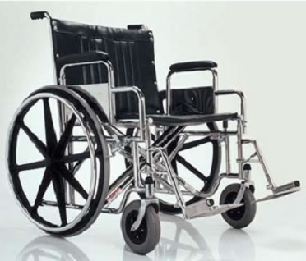 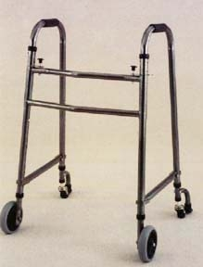 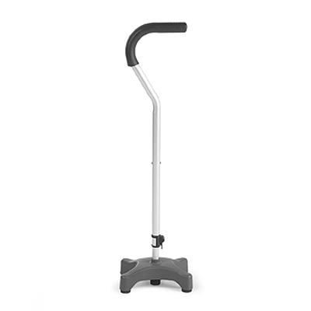

Lift in home\_\_\_\_ Shower chair or

tub-transfer bench \_\_\_\_\_\_ 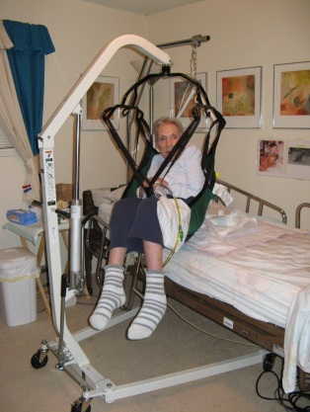 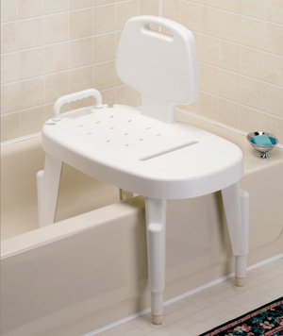

Specially equipped vehicle \_\_\_ Model \_\_\_\_\_\_\_\_\_\_\_\_\_\_\_\_\_\_\_\_\_\_\_\_

License Number \_\_\_\_\_\_\_\_\_\_\_\_\_\_\_\_\_\_\_\_\_\_

If you use a wheelchair, can you transfer into a seat in a car or van?

Yes \_\_\_\_ No \_\_\_

Check if you can you use public transportation or Para transit \_\_\_\_

**MCj04347130000[1]** Find out the place where you bought any equipment (vendor) and the vendor’s phone number, and whether or not it needs batteries. Name someone who knows how to work the equipment. See the following examples.

Examples:

**Daily living equipment needed:**

**Type Vendor Phone Number Batteries? Electricity?**

Hoyer lift MobilityInc. 914 567-5678 Yes (back-up) Yes

**Type Vendor Phone Number Batteries? Electricity?**

**People who know how to work equipment:** Mary Jones

**Mobility Equipment Needed:**

**Type/Model Vendor Phone Number Batteries? Electricity?**

Motorized wheelchair MobilityInc. 914 567-5678 Yes (back-up) Yes

**Type/Model Vendor Phone Number Batteries? Electricity?**

Dodge Caravan Accessible Motors 914-552-5053

License # 123-4K4

**People who know how to work equipment:** Mary Jones and John Smith

**Daily living equipment needed:**

**Type Vendor Phone Number Batteries? Electricity?**

**Type Vendor Phone Number Batteries? Electricity?**

**People who know how to work equipment:**

**Mobility Equipment Needed:**

**Type/Model Vendor Phone Number Batteries? Electricity?**

**Type/Model Vendor Phone Number Batteries? Electricity?**

**People who know how to work equipment:**

A service animal must stay with you if you need to evacuate. It must be allowed to be with you even if you go to a shelter that does not allow animals. Make sure it has an ID tag. **MCj04347130000[1]** Find out its license number and record of vaccinations. Include the information in the box below.

Example:

**I have a service animal named** Pepper **who must stay with me.**

**License or ID Number:** 303KLM

**Vaccinations:** Rabies, 3/19/09

**I have a service animal named who must stay with me.**

**License or ID Number:**

**Vaccinations:**

If you have a pet, you must plan on where it will go in an emergency. Pets may not be allowed in a shelter. If you cannot bring them with you, make arrangements with friends, relatives, or a kennel ahead of time.

**Daily activities**

Do you need help with any of the following activities?

bathing \_\_\_going to the toilet \_\_\_ brushing your teeth \_\_\_ dressing \_\_\_ getting in and out of bed \_\_\_eating \_\_\_ drinking \_\_

Do you use any special utensils to help you eat independently? \_\_\_\_

Do you need help with walking quickly in an emergency? \_\_\_\_

Include the above information and anything else you may need help with in the HELP or SAFETY boxes. See the Examples below.

**I need HELP with:**

Getting on and off the toilet, brushing my teeth.

Getting in the bathtub, washing my back.

**To HELP me eat, I need:**

My food must be chopped up, I can’t chew well. I must use a spoon.

*Things to Remember*

***Things to Review***

**SAFETY PRECAUTIONS**

I am unsteady without a walker and need assistance.

In an emergency I may need to be carried.

**I need HELP with:**

**To HELP me eat, I need:**

*ember*

***ew***

**SAFETY PRECAUTIONS**

*member*

***iew***

**Go to Form C of *Personal Emergency Plan* BD21298_ Communication/ Emotional Needs**

It is important for you to understand people who are trying to help you. It is important for them to understand you. Answer the following questions and include the information in the box below.

What language do you understand? \_\_\_\_\_\_\_\_\_\_\_\_\_\_\_\_\_\_\_\_\_\_\_\_\_

What is the best way for you to communicate? Speaking \_\_\_ Braille \_\_\_ Written words \_\_\_ Pictures and symbols \_\_\_ Sign language \_\_\_ Communication Device \_\_\_

**MCj04347130000[1]** If you use a communication device, find out the type, the place where you got it (vendor) and its phone number, and if it needs batteries.

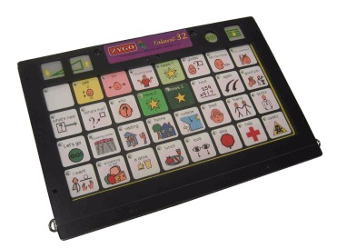Do you have trouble hearing or seeing? Yes \_\_ No \_\_\_

Check off if you use eyeglasses, contacts, hearing aids, or dentures in the box below. Example:

**I understand \_\_**English**\_\_\_\_\_\_\_ I can read words \_\_\_ pictures \_\_\_ Braille \_\_\_**

**I use sign language \_\_\_\_\_\_\_\_ I use hand/head movements \_\_\_\_X\_\_**

**I use a Communication Device:**

**Type:** Bluebird II

**Vendor Name/Phone:** MedEquip 212-333-2232

**Batteries/Electricity:** rechargeable batteries; also AC backup

**I have a hearing problem** yes **I have a visual impairment** no

**I wear eyeglasses \_\_\_ contact lenses \_\_\_ hearing aids \_\_x\_ dentures \_\_\_\_**

**I understand \_\_\_\_\_\_\_\_\_\_\_\_\_\_ I can read words \_\_\_ pictures \_\_\_ Braille \_\_\_**

**I use sign language \_\_\_\_\_\_\_\_ I use hand/head movements \_\_\_\_\_\_\_\_\_**

**I use a Communication Device:**

**Type \_\_\_\_\_\_\_\_\_\_\_\_\_**

**Vendor Name/Phone \_\_\_\_\_\_\_\_\_\_\_\_\_\_\_\_\_\_\_\_\_\_**

**Batteries/Electricity: \_\_\_\_\_\_\_\_\_\_\_\_\_\_\_\_\_\_\_\_\_**

**I have a hearing problem \_\_\_\_\_\_ I have a visual impairment \_\_\_\_\_\_\_\_\_\_\_\_\_**

**I wear eyeglasses \_\_\_ contact lenses \_\_\_ hearing aids \_\_\_ dentures \_\_\_\_**

Emergencies can be very scary. You may feel upset, nervous, confused, or even sick to your stomach! Maybe noise or flashing lights bother you. Sometimes you may act in a way that another person does not understand. It is important to let others know how you might feel and act in an emergency. Think carefully about this and write down what is important to know about you.

Example:

**During an emergency I may FEEL or ACT:**

I get upset when I am rushed and I may not want to move.

When I am upset I may not be able to understand what you are saying.

I get confused when I feel stressed and I may try to run away.

**During an emergency I may FEEL or ACT:**

Sometimes there are things others can do to help you feel calm in an emergency. Write down what would help you feel better.

**MCj04347130000[1]** It is a good idea to talk to a family member or friend about how you might feel or act during an emergency and what would calm you down.

Example:

**To help CALM me, I would like you to:**

Speak slowly and calmly. Use simple sentences.

Give me directions step-by-step.

Do not push me; take me gently by the arm.

Do not leave me alone.

**To help CALM me, I would like you to:**

Sometimes it helps to bring something special with you if you must leave your home. For example, you may want to bring your special book or a photo. Write down your special item below.

Example:

**I need to bring \_\_\_**my photo album**\_\_\_\_\_\_\_\_\_\_with me to help me feel better.**

**I need to bring \_\_\_\_\_\_\_\_\_\_\_\_\_\_\_\_\_\_\_\_\_\_\_\_with me to help me feel better.**

It is necessary to have identification with you if you need to leave your home. Do you have a photo ID? Yes \_\_\_ No \_\_\_

* If not, talk to your support person about getting one.
* **Go to Form D of *Personal Emergency Plan* BD21298_**

All of this information is very important to have in your ***Personal Emergency Plan*.** It is also a good idea to have a one-page summary of your health needs that you can show to someone right away. You should keep it with you at all times in case you have an emergency when you are away from home. Look at the example of ***My Health Summary*** to see how you can complete your own information. Remember to always keep it up to date!

|  |  |  |  |  |  |  |  |  |  |  |  |  |  |  |  |  |  |
| --- | --- | --- | --- | --- | --- | --- | --- | --- | --- | --- | --- | --- | --- | --- | --- | --- | --- |
| **MY HEALTH SUMMARY**  ***SAMPLE*** | | | | | | | | | | | | | | | | | |
| **NAME:**  Lee Smith  **Address:**34 Oak Street, Valhalla, NY 10532  **Phone Number(s):** 914-552-5553 Lee’s Cell: 917-555-6543; Mary’s cell:917-555-1234  **Date of Birth:** 2/14/78  **Blood Type:** B positive  **Weight:** 115 Lbs**. Safety Alert:** No MRI, magnet in head; may hide during emergency | | | | | | | | | | | | | | | | | |
| **CONTACT Name** | | | | | | | **Phone Number** | | | | | | | **Address** | | | |
| Mary Jones, 914-123-1356 | | | | | | | 914-123-1356 | | | | | | | 23 Elm St. White Plains, NY | | | |
| **LEGAL GUARDIAN:** John and Jane Smith, 914-333-3332 | | | | | | | | | | | | | | | | | |
| **MEDICAL INSURANCE** | | | | | | | | **Policy Number** | | | | | | | | **Group Number** | |
| Aetna | | | | | | | | 345678JKL | | | | | | | | S28 | |
| Medicaid | | | | | | | | DR12345M | | | | | | | |  | |
| **PHYSICIAN(S)** | | | | | **Phone Number** | | | **Address** | | | | | | | | | **Fax Number** |
| Dr. Michael Brown | | | | | 914-777-7777 | | | 12 Main St., Yonkers, NY 10332 | | | | | | | | | 914-777-7722 |
| Dr. Maria Gomez, neurologist | | | | | 914-666-9999 | | | Health Clinic, White Plains, NY | | | | | | | | | 914-666-9900 |
| **ALLERGIES / REACTION** | | | | | | | | | | | | | | | | | |
| amoxicillin – causes rash; bee stings – difficulty breathing | | | | | | | | | | | | | | | | | |
| **MEDICAL CONDITIONS/DIAGNOSIS/BASELINE DATA** | | | | | | | | | | | | | | | | | |
| Cerebral palsy; intellectual disability; Seizure disorder; asthma  Orthopedic abnormalities: kyphosis, abnormal left hip and shortened left leg;  Major hip surgeries; pin remains in left hip | | | | | | | | | | | | | | | | | |
| **ONGOING MEDICAL TREATMENTS/LOCATION/ALTERNATE SITE** | | | | | | | | | | | | | | | | | |
| Nebulizer; twice daily at home; dialysis, White Plains Health Clinic (alternate: Danbury Hospital, CT.) | | | | | | | | | | | | | | | | | |
| **IMMUNIZATIONS** | | | | | | | | | | | | | | | | | |
| **Type** | | **Dates** | | | | | | | | **Type** | | | | | **Dates** | | |
| Tetanus  PPD (Mantoux) | | 10/01/09  10/01/09 | | | | | | | | Influenza  Hepatitis B | | | | | 10/01/09  2/10/08,3/12/08, 9/1/08 | | |
| **CURRENT MEDICATIONS** | | | | | | | | | | | | | | | | | |
| **Medication** | **Dosage** | | | | | **How Much/How Often/When Taken** | | | | | | | | | **Doctor who Prescribed** | | |
| Lamictal  Albuteral | 200mg.  500 mg. | | | | | 2tabs / 2 times a day**/**a.m. & p.m.  1 puff / As needed | | | | | | | | | Dr. Gomez  Dr. Brown | | |
| **Pharmacy/Address:**  Health Pharmacy, White Plains, NY  **Pharmacy Phone Number:** 914-888-8888 **Fax** **Number:** 914-888-8866 | | | | | | | | | | | | | | | | | |
| **MEDICAL/ MOBILITY AIDS/DEVICES** | | | | | | | | | | | | | | | | | |
| **Name** | | | | **Vendor** | | | | | **Phone Number** | | | | **Electricity/Batteries?** | | | | |
| Nebulizer  Motorized wheelchair | | | | MedEquip, Inc.  Mobility, Inc. | | | | | | 212-333-2232  914 567-5678 | | | Needs elec. No battery.  Needs elec, Back-up batt. | | | | |
| **DAILY LIVING AIDS/SPECIAL INSTRUCTIONS/SERVICE ANIMAL** | | | | | | | | | | | | | | | | | |
| Uses eyeglasses; Needs food chopped; cannot chew, cannot use straw  May run away during emergency situation  Service dog – Pepper, License # 303KLM, Rabies vaccine 9/15/09 | | | | | | | | | | | | | | | | | |
| **COMMUNICATION DEVICES** | | | | | | | | | | | | | | | | | |
| **Name** | | | **Vendor** | | | | | | **Phone Number** | | **Electricity/Batteries?** | | | | | | |
| Bluebird II | | | | MedEquip, Inc. | | | | | | 212-333-2232 | | Rechargeable battery | | | | | |

**Section 3: Your Support People**

**Things we’ll do**

* Discuss who are my support people
* Discuss the importance of having support people in an emergency
* Complete ***My Routine Activities***

**After this section I will**

* See how my schedule will fit into my emergency plan
* Have a list of support people
* Know how my support people can help me

**MCj04347130000[1]After this section I need to**

* Talk to each of my support people about how they can help me
* Show support people how to use any equipment I need
* Give at least one support person the key to my home
* Complete **Contact Information** section of my ***Personal Emergency Plan***

**Who are your support people?**

During an emergency you will need people to support you. If you need to leave a building quickly, a fire person or a police officer is often the one to assist you. But other people like neighbors, co-workers, friends, or church members may also be able to help you. In fact they may be there first. It is important for you to know what people are available to support you on different days of the week and at different places. You will list these support people on the ***My Routine Activities*** form.Give them all the information about yourself on your ***Personal Emergency Plan*** so they know how they can best help you. You may have to show them some things like how to best guide or carry you if necessary.

**How will your support persons help you?**

Support people are a necessary part of emergency planning. They can:

* Let you know if an emergency happens
* Help you reach your contact persons
* Assist you in walking if needed
* Know how to work your medical and other equipment
* Make sure you have the supplies you need ahead of time
* Know where you will go in case of an evacuation
* Help you to arrange for transportation ahead of time
* Make sure you know what to do if you must stay in your home
* Check on you while you are in your home
* Help you when you return home after an evacuation

**My Routine Activities**

Since an emergency can happen at any time, it is important to think about all of the places you go during the week. You might be at home, work, a day habilitation program, a therapy session, a recreation program or class, a special event, or on the road. It is helpful to write down your routine activities. Think about who would be your support person at each place if an emergency happens. Fill in the information on the ***My Routine Activities***form. Look at the following sample to give you some ideas of the places you might be.

***My Routine Activities***

***SAMPLE***

**List all the places you are during the week. Include home, work, day programs, recreation, school or classes, rehabilitation, or medical treatments. Write down the name of the person who can support you if you need help at each place.**

1. **Place: \_\_\_\_\_\_\_**Home**\_\_\_\_\_\_\_\_\_\_\_\_\_\_\_\_\_\_\_\_\_\_\_\_\_\_\_\_\_\_\_\_\_\_\_\_\_\_\_\_\_\_\_**

**Type of Activity: \_\_\_**relaxing**\_\_\_\_\_\_\_\_\_\_\_\_\_\_\_\_\_\_\_\_\_\_\_\_\_\_\_\_\_\_\_\_\_\_\_\_\_\_\_**

**Name of Support Person: \_\_\_**Fred White (upstairs neighbor)**\_\_\_\_\_\_\_\_\_\_\_\_\_\_\_**

**How will help me \_**tell me if there is an emergency; help me out of my building\_\_

1. **Place: \_\_\_\_** Able, Inc. **\_\_\_\_\_\_\_\_\_\_\_\_\_\_\_\_\_\_\_\_\_\_\_\_\_\_\_\_\_\_\_\_\_\_\_\_\_\_\_\_\_\_**

**Type of Activity: \_\_\_**Day Habilitation**\_\_\_\_\_\_\_\_\_\_\_\_\_\_\_\_\_\_\_\_\_\_\_\_\_\_\_\_\_\_\_\_\_**

**Name of Support Person: \_\_**Jose Gomez**\_\_\_\_\_\_\_\_\_\_\_\_\_\_\_\_\_\_\_\_\_\_\_\_\_\_\_\_\_\_**

**How will help me \_\_\_\_\_\_\_**tell me where I have to go**\_\_\_\_\_\_\_\_\_\_\_\_\_\_\_\_\_\_\_\_**

1. **Place: \_\_\_\_**ShopRite\_\_\_\_\_\_\_\_\_\_\_\_\_\_\_\_\_\_\_\_\_\_\_\_\_\_\_\_\_\_\_\_\_\_\_\_\_\_\_\_\_\_\_

**Type of Activity: \_\_**work**\_\_\_\_\_\_\_\_\_\_\_\_\_\_\_\_\_\_\_\_\_\_\_\_\_\_\_\_\_\_\_\_\_\_\_\_\_\_\_\_\_\_\_**

**Name of Support Person:** \_\_\_Jean John**\_\_\_\_\_\_\_\_\_\_\_\_\_\_\_\_\_\_\_\_\_\_\_\_\_\_\_\_\_\_**

**How will help me \_\_\_\_\_\_\_\_**call my contact person**\_\_\_\_\_\_\_\_\_\_\_\_\_\_\_\_\_\_\_\_\_\_**

1. **Place: \_\_**Westchester Wellness Center**\_\_\_\_\_\_\_\_\_\_\_\_\_\_\_\_\_\_\_\_\_\_\_\_\_\_\_\_\_**

**Type of Activity: \_\_\_\_\_**physical therapy**\_\_\_\_\_\_\_\_\_\_\_\_\_\_\_\_\_\_\_\_\_\_\_\_\_\_\_\_\_\_\_**

**Name of Support Person: \_\_\_\_**Lee Gold**\_\_\_\_\_\_\_\_\_\_\_\_\_\_\_\_\_\_\_\_\_\_\_\_\_\_\_\_\_\_\_**

**How will help me \_\_\_\_\_\_\_\_**hold my arm while I walk quickly**\_\_\_\_\_\_\_\_\_\_\_\_\_\_\_**

1. **Place:** \_\_\_\_\_Ability-on-the-go Recreation\_\_\_\_\_\_\_\_\_\_\_\_\_\_\_\_\_\_\_\_\_\_\_\_\_\_\_

**Type of Activity:** \_\_\_bowling\_\_\_\_\_\_\_\_\_\_\_\_\_\_\_\_\_\_\_\_\_\_\_\_\_\_\_\_\_\_\_\_\_\_\_\_\_\_\_\_

**Name of Support Person:** \_\_\_\_\_\_\_\_\_\_\_\_Tanya Smith\_\_\_\_\_\_\_\_\_\_\_\_\_\_\_\_\_\_\_\_

**How will help me \_\_\_\_\_\_\_\_\_\_\_**keep me calm**\_\_\_\_\_\_\_\_\_\_\_\_\_\_\_\_\_\_\_\_\_\_\_\_\_\_**

***My Routine Activities***

**List all the places you are during the week. Include home, work, day programs, recreation, school or classes, rehabilitation, or medical treatments. Write down the name of the person who can support you if you need help at each place.**

1. **Place: \_\_\_\_\_\_\_**\_\_\_\_\_\_\_\_\_\_**\_\_\_\_\_\_\_\_\_\_\_\_\_\_\_\_\_\_\_\_\_\_\_\_\_\_\_\_\_\_\_\_\_\_\_\_\_\_\_\_\_\_**

**Type of Activity: \_\_\_\_\_\_\_\_\_\_\_\_\_\_\_\_\_\_\_\_\_\_\_\_\_\_\_\_\_\_\_\_\_\_\_\_\_\_\_\_\_\_\_\_\_\_\_\_\_\_\_\_\_**

**Name of Support Person: \_\_\_\_\_\_\_\_\_\_\_\_\_\_\_\_\_\_\_\_\_\_\_\_\_\_\_\_\_\_\_\_\_\_\_\_\_\_\_\_\_\_\_\_\_\_**

**How will help me \_\_\_\_\_\_\_\_\_\_\_\_\_\_\_\_\_\_\_\_\_\_\_\_\_\_\_\_\_\_\_\_\_\_\_\_\_\_\_\_\_\_\_\_\_\_\_\_\_\_\_\_**

1. **Place: \_\_\_\_\_\_\_**\_\_\_\_\_\_\_\_\_\_**\_\_\_\_\_\_\_\_\_\_\_\_\_\_\_\_\_\_\_\_\_\_\_\_\_\_\_\_\_\_\_\_\_\_\_\_\_\_\_\_\_\_**

**Type of Activity: \_\_\_\_\_\_\_\_\_\_\_\_\_\_\_\_\_\_\_\_\_\_\_\_\_\_\_\_\_\_\_\_\_\_\_\_\_\_\_\_\_\_\_\_\_\_\_\_\_\_\_\_\_**

**Name of Support Person: \_\_\_\_\_\_\_\_\_\_\_\_\_\_\_\_\_\_\_\_\_\_\_\_\_\_\_\_\_\_\_\_\_\_\_\_\_\_\_\_\_\_\_\_\_\_**

**How will help me \_\_\_\_\_\_\_\_\_\_\_\_\_\_\_\_\_\_\_\_\_\_\_\_\_\_\_\_\_\_\_\_\_\_\_\_\_\_\_\_\_\_\_\_\_\_\_\_\_\_\_\_**

1. **Place: \_\_\_\_\_\_\_**\_\_\_\_\_\_\_\_\_\_**\_\_\_\_\_\_\_\_\_\_\_\_\_\_\_\_\_\_\_\_\_\_\_\_\_\_\_\_\_\_\_\_\_\_\_\_\_\_\_\_\_\_**

**Type of Activity: \_\_\_\_\_\_\_\_\_\_\_\_\_\_\_\_\_\_\_\_\_\_\_\_\_\_\_\_\_\_\_\_\_\_\_\_\_\_\_\_\_\_\_\_\_\_\_\_\_\_\_\_\_**

**Name of Support Person: \_\_\_\_\_\_\_\_\_\_\_\_\_\_\_\_\_\_\_\_\_\_\_\_\_\_\_\_\_\_\_\_\_\_\_\_\_\_\_\_\_\_\_\_\_\_**

**How will help me \_\_\_\_\_\_\_\_\_\_\_\_\_\_\_\_\_\_\_\_\_\_\_\_\_\_\_\_\_\_\_\_\_\_\_\_\_\_\_\_\_\_\_\_\_\_\_\_\_\_\_\_**

1. **Place: \_\_\_\_\_\_\_**\_\_\_\_\_\_\_\_\_\_**\_\_\_\_\_\_\_\_\_\_\_\_\_\_\_\_\_\_\_\_\_\_\_\_\_\_\_\_\_\_\_\_\_\_\_\_\_\_\_\_\_\_**

**Type of Activity: \_\_\_\_\_\_\_\_\_\_\_\_\_\_\_\_\_\_\_\_\_\_\_\_\_\_\_\_\_\_\_\_\_\_\_\_\_\_\_\_\_\_\_\_\_\_\_\_\_\_\_\_\_**

**Name of Support Person: \_\_\_\_\_\_\_\_\_\_\_\_\_\_\_\_\_\_\_\_\_\_\_\_\_\_\_\_\_\_\_\_\_\_\_\_\_\_\_\_\_\_\_\_\_\_**

**How will help me \_\_\_\_\_\_\_\_\_\_\_\_\_\_\_\_\_\_\_\_\_\_\_\_\_\_\_\_\_\_\_\_\_\_\_\_\_\_\_\_\_\_\_\_\_\_\_\_\_\_\_\_**

1. **Place: \_\_\_\_\_\_\_**\_\_\_\_\_\_\_\_\_\_**\_\_\_\_\_\_\_\_\_\_\_\_\_\_\_\_\_\_\_\_\_\_\_\_\_\_\_\_\_\_\_\_\_\_\_\_\_\_\_\_\_\_**

**Type of Activity: \_\_\_\_\_\_\_\_\_\_\_\_\_\_\_\_\_\_\_\_\_\_\_\_\_\_\_\_\_\_\_\_\_\_\_\_\_\_\_\_\_\_\_\_\_\_\_\_\_\_\_\_\_**

**Name of Support Person: \_\_\_\_\_\_\_\_\_\_\_\_\_\_\_\_\_\_\_\_\_\_\_\_\_\_\_\_\_\_\_\_\_\_\_\_\_\_\_\_\_\_\_\_\_\_**

**How will help me \_\_\_\_\_\_\_\_\_\_\_\_\_\_\_\_\_\_\_\_\_\_\_\_\_\_\_\_\_\_\_\_\_\_\_\_\_\_\_\_\_\_\_\_\_\_\_\_\_\_\_\_**

1. **Place: \_\_\_\_\_\_\_**\_\_\_\_\_\_\_\_\_\_**\_\_\_\_\_\_\_\_\_\_\_\_\_\_\_\_\_\_\_\_\_\_\_\_\_\_\_\_\_\_\_\_\_\_\_\_\_\_\_\_\_\_**

**Type of Activity: \_\_\_\_\_\_\_\_\_\_\_\_\_\_\_\_\_\_\_\_\_\_\_\_\_\_\_\_\_\_\_\_\_\_\_\_\_\_\_\_\_\_\_\_\_\_\_\_\_\_\_\_\_**

**Name of Support Person: \_\_\_\_\_\_\_\_\_\_\_\_\_\_\_\_\_\_\_\_\_\_\_\_\_\_\_\_\_\_\_\_\_\_\_\_\_\_\_\_\_\_\_\_\_\_**

**How will help me \_\_\_\_\_\_\_\_\_\_\_\_\_\_\_\_\_\_\_\_\_\_\_\_\_\_\_\_\_\_\_\_\_\_\_\_\_\_\_\_\_\_\_\_\_\_\_\_\_\_\_\_**

1. **Place: \_\_\_\_\_\_\_**\_\_\_\_\_\_\_\_\_\_**\_\_\_\_\_\_\_\_\_\_\_\_\_\_\_\_\_\_\_\_\_\_\_\_\_\_\_\_\_\_\_\_\_\_\_\_\_\_\_\_\_\_**

**Type of Activity: \_\_\_\_\_\_\_\_\_\_\_\_\_\_\_\_\_\_\_\_\_\_\_\_\_\_\_\_\_\_\_\_\_\_\_\_\_\_\_\_\_\_\_\_\_\_\_\_\_\_\_\_\_**

**Name of Support Person: \_\_\_\_\_\_\_\_\_\_\_\_\_\_\_\_\_\_\_\_\_\_\_\_\_\_\_\_\_\_\_\_\_\_\_\_\_\_\_\_\_\_\_\_\_\_**

**How will help me \_\_\_\_\_\_\_\_\_\_\_\_\_\_\_\_\_\_\_\_\_\_\_\_\_\_\_\_\_\_\_\_\_\_\_\_\_\_\_\_\_\_\_\_\_\_\_\_\_\_\_\_**

You will also need to think of who will be your main **Contact Person**. This should be a family member, legal guardian, or close friend. This is the person you will call to plan what to do next. It should be someone who lives nearby. It is helpful to also have a contact that lives in another area. Sometimes in an emergency it is easier to reach a person who lives farther away if the local phone lines are too busy. Write your contact names below.

**Contact List**

Main Contact Person(s) \_\_\_\_\_\_\_\_\_\_\_\_\_\_\_\_\_\_\_\_\_\_\_\_\_\_\_\_\_\_\_\_\_\_\_\_\_\_\_\_\_

Phone number\_\_\_\_\_\_\_\_\_\_\_\_\_\_\_\_\_\_\_\_\_\_\_\_\_\_\_\_\_\_\_\_\_\_\_\_\_\_\_\_\_\_\_\_

Out-of-town Contact \_\_\_\_\_\_\_\_\_\_\_\_\_\_\_\_\_\_\_\_\_\_\_\_\_\_\_\_\_\_\_\_\_\_\_\_\_\_\_\_\_\_\_

Phone number \_\_\_\_\_\_\_\_\_\_\_\_\_\_\_\_\_\_\_\_\_\_\_\_\_\_\_\_\_\_\_\_\_\_\_\_\_\_\_\_\_\_\_

* Speak to all of your support persons from your activities list and contact persons to make sure they are willing and able to help you. Get their correct phone numbers and addresses. Tell each one what help you might need. Be sure to include a neighbor who can help if you must leave your home quickly! Once you have a final list of support people include them on the **Contact Information** form in your ***Personal Emergency Plan***.
* Give a key to your home to one or two of your support people.
* **Go to Form E of *Personal Emergency Plan* BD21298_**

***Things to Remember***

* Support people are those people who can help you in an emergency.
* Your list of support people should include people from the different places that you are during the week.
* Support people can help you in many different ways.
* Ask your support people if they are able to help you in an emergency.
* Tell or show them how they can help you.
* You must also have a main contact person and another contact that lives out of your area.

**Section 4: What You Need to Plan to Be Safe**

**Things we’ll do**

* Review ways to find out about an emergency
* Talk about ways to contact family members and support persons
* Discuss transportation and what to do if I must leave my home

**After this section I will**

* Understand how I will know when there is an emergency
* Know how I will contact my support people
* Know where I will go if I must leave home and how I will get there

**MCj04347130000[1]After this section I need to**

* Visit my local town hall or fire department
* Discuss my emergency plans with my support people
* Sign up for a local registry
* Complete **Steps in an Emergency** form in my ***Personal Emergency Plan***
* Decide where to put my **Steps in an Emergency** form

**How will you know there is an emergency?**

Ask your support people to let you know if there is an emergency and you must evacuate. It is also important to let your community know where you live and that you might need assistance during an emergency. **MCj04347130000[1]** It is helpful to visit your local town hall or fire department to talk about your needs. You may have to call first for an appointment.

Some towns and counties will call your home in an emergency if you are on their registry. They may also send emergency people to come knock on your door if necessary. Learn about any siren system in your neighborhood. Listen to the radio and watch your local television station. You may receive important information about what to do. Since you may lose power during an emergency, it is important to have a battery-powered or wind-up radio and extra batteries. **MCj04347130000[1]** Talk to your support people about signing up for a registry if your town or county has one.

**How will you communicate during an emergency?**

You must think about how you will reach your contact people during an emergency. It is helpful to have a land line phone that will work if the electricity is out. Sometimes the phone lines don’t work so a cell phone may be helpful. But cell phones might not work either. You may be able to reach someone by e-mail or text message. Decide with your support people other ways to let them know you need help. If your support people are close by, you can use a whistle to let them know you need help.

MCSL00360_0000[1]

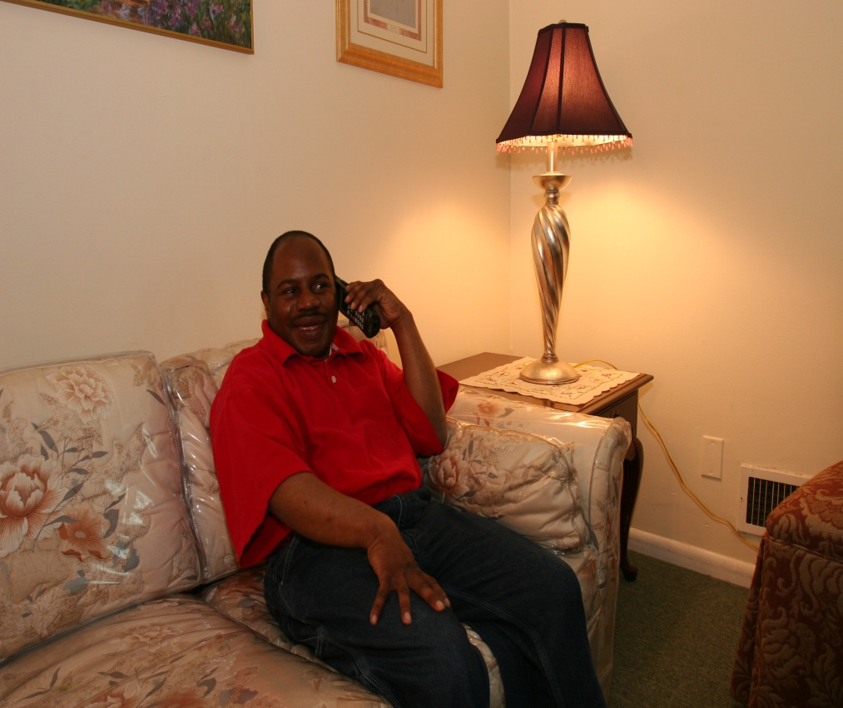

**What transportation do you use?**

**MCj04347130000[1]** Discuss with your support people what type of transportation you will use if you must leave your home. If you need a special van, make sure that some of your support people know how to work it. You should have the information about your vehicle written on your ***Personal Emergency Plan***. If you usually use public transportation or Para Transit, remember that during an emergency they may not run. So you must plan on another way to travel. You could have one of your support people plan to drive you.

**Where will you go?**

You should plan ahead where you will go if you must leave your home. It is best if you can stay with family or friends. **MCj04347130000[1]**Talk to them ahead of time. However, if that is not possible you may need to go to a shelter. Emergency people will tell you where the nearest shelter is located. If you have special needs you must make sure the shelter has what you need.

Service animals should be with you wherever you go. If you have a pet, however, you must plan ahead where the pet will go. If the pet is not able to go with you, locate friends or animal shelters that might take it.

**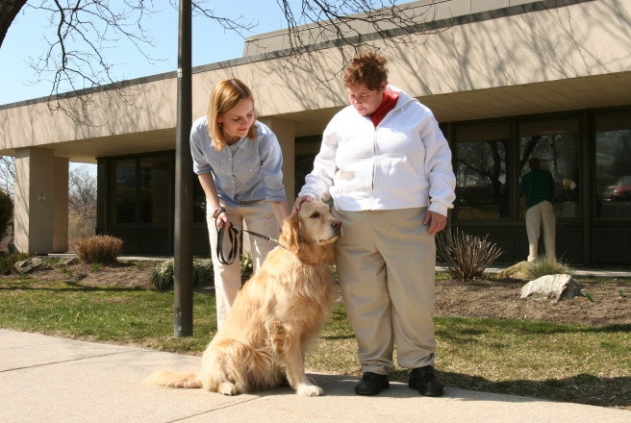**

**MCj04347130000[1]** After you speak to your support persons about your needs, complete the **Steps in an Emergency** form (**Form G**). See the example on the following page.

This form tells you what to do if you must leave your home in an emergency. **MCj04347130000[1]**Put it somewhere where you can see it quickly and easily. For example, you can put it on a bulletin board or refrigerator in your home. Remember to keep it up-to-date and to **look at it** in an emergency!

Do not use this form in case of a fire. You will complete an **Escape Plan** in the section called **Fire Safety**. You must get out fast in a fire and the **Escape Plan** will show you how to do it.

* **Go to Form G of *Personal Emergency Plan* BD21298_**

**Steps In An Emergency**

***SAMPLE***

1. **I will know there is an emergency because:**

Mary Jones will call me on my phone.

The county will call me.

I will hear it on the radio.

1. **I will call (contact/support person):**

My upstairs neighbor, Fred White 914 -665-8976

My contact, Mary Jones, 914-333-3333

1. **For transportation I will call:** Ambulette Services, 914 -557-1234

My friend Jose who has a car, 914-552-5252

1. **Let others know how they can help me.**

I am unsteady without a walker and need assistance.

In an emergency I may need to be carried.

I get upset when I am rushed and I may not want to move.

When I am upset I may not be able to understand what you are saying.

I get confused when I feel stressed and I may try to run away.

1. **Take Go-Bag with *Personal Emergency Plan* in it.**
2. **Go to:** Aunt Rosie’s house - 123 Spring Street, Greenwich, Ct.
3. **Call out-of-area contact:** Ed Black,215-554-4444

(E-mail address):eblack@gmail.com

**IF I AM HURT**

**I WILL CALL 911**

***Things to Remember***

* Ask a support person to let you know if there is an emergency. Sign up for any alert system that can contact you.
* Review what type of transportation you will use if you need to leave your home.
* Plan on the different ways you can reach your support people in an emergency.
* Visit your local town hall or fire department and let them know of your needs.
* Plan on where you can go for a few days if you must leave your home.
* Include all of this information on the ***Steps in an Emergency*** Form.

**Section 5**: **What You Need to Have in an Emergency**

**Things we’ll do**

* Review what items I need to have in my home during an emergency
* Discuss what I want to take with me if I have to leave my house

**After this section I will**

* Know what items I need to get for my home and my Go-Bag
* Understand what important documents I have to get together

**MCj04347130000[1]After this section I need to**

* Start gathering items for my **Basic Supplies Home Kit** and **Go-bag**
* Make copies of my important documents to include in my ***Personal Emergency Plan*** folder

**What supplies do you need in an emergency?**

An important part of being prepared for an emergency is to have the supplies you will need. There are times when you may have to stay in your home for a few days such as during a bad snow storm. At other times you may have to leave your home, such as during a hurricane or flood. You need to be prepared for both.

You should have a **Basic Supplies Home Kit** that you keep in your home to use when you cannot leave your home. You should also have a smaller kit or **Go-bag** that you can take with you if you must leave your home.

If you must stay in your home, you need to have food and water. It is possible that you may not have electricity or gas so you need to store food that does not have to be refrigerated or heated, like tuna fish or granola bars. Make sure you have a can opener that is not electric! Put the date on the food items. Water is the most important item to have. Buy water or keep water in clean plastic soda bottles. If you run out of water and you cannot get clean water, then add bleach to it. Put 16 drops (1/4 teaspoon) of bleach into a gallon of water or 8 drops into a liter or soda bottle of water. Let it sit 30 minutes before you drink it.

You will need to have supplies of your personal items like soap, shampoo, toothpaste, and deodorant. Make sure you have at least a week’s worth of your prescription medicine and other medicines like aspirin or laxatives. Include a battery-powered or wind-up flashlight and radio in your **Basic Supplies Home Kit**. Make sure you have extra batteries. Think about all the items you use in your home such as toilet paper, paper towels, and first aid items. You probably have most of these items in your home already. You have shampoo and toilet paper in the bathroom and paper towels in the kitchen. In an emergency you may not be able to get to these items easily. An example is if the lights go out in your home. It would be very helpful if all the items you need are in one place.

Check the dates on your food and water supply every few months to make sure nothing has expired. If it is past the date, replace the food item with a new one.

***Basic Supplies Home Kit Checklist***

Review this **Checklist** to make sure you have everything you need if you cannot leave your home for a few days.

\* Water, 3 – day supply \_\_\_\_ Household bleach (unscented) \_\_\_\_

Food, 3-day supply (does not need refrigeration or heat) \_\_\_\_\_

Manual can opener \_\_\_\_\_

Medications (7 day supply) \_\_\_\_\_

Medical supplies: Catheters \_\_\_\_\_ Tubing \_\_\_\_\_ Syringes \_\_\_\_\_ Diabetes supplies \_\_\_\_ Inhalator \_\_\_\_\_Nebulizer \_\_\_\_\_\_ Oxygen \_\_\_ Dressings \_\_\_\_\_\_Other \_\_\_\_\_\_\_\_\_\_\_\_\_\_\_\_\_\_

Over-the-counter medications: Pain reliever \_\_\_ Laxative \_\_\_ Antacid \_\_\_\_ Vitamins \_\_\_ Other \_\_\_

Radio, battery-powered or wind-up \_\_\_\_\_ Batteries \_\_\_\_\_

Flashlight, battery-powered or wind-up \_\_\_\_\_\_ Batteries \_\_\_\_

Whistle \_\_\_\_\_\_ Blankets to keep warm \_­­­­­­­­­­­­­­­­­­­­­­­­­­\_\_\_\_\_\_

Personal Hygiene Items: Shampoo \_\_\_\_\_ Soap \_\_\_\_\_ Toothpaste \_\_\_\_\_ Deodorant \_\_\_\_\_ Toilet Paper \_\_\_\_\_\_\_Sanitary supplies \_\_\_\_\_ Denture cleaner and case \_\_\_\_\_ Contact lens cleaner and case \_\_\_\_\_

First Aid Supplies: Bandages \_\_\_ Sterile gauze \_\_\_ Tape \_\_\_ Scissors \_\_\_ Tweezers \_\_ Alcohol \_\_\_\_

Extra set of clothes \_\_\_\_\_\_\_

Baby supplies (if needed) \_\_\_\_\_\_\_\_\_\_\_\_\_\_\_\_\_\_\_\_\_\_\_\_\_\_\_\_\_\_\_\_\_\_\_\_

Pet supplies (if needed) \_\_\_\_\_\_\_\_\_\_\_\_\_\_\_\_\_\_\_\_\_\_\_\_\_\_\_\_\_\_\_\_\_\_\_\_\_\_

**What is a Go-bag?**

If you must leave your home, you should have a **Go-bag** that you can grab quickly. It will include some of the same items that you have in your basic kit like personal, sanitary, and first aid items. But it will also include extra medication, medical supplies, and important documents. Review the ***Go-bag Checklist*** to see what to include.

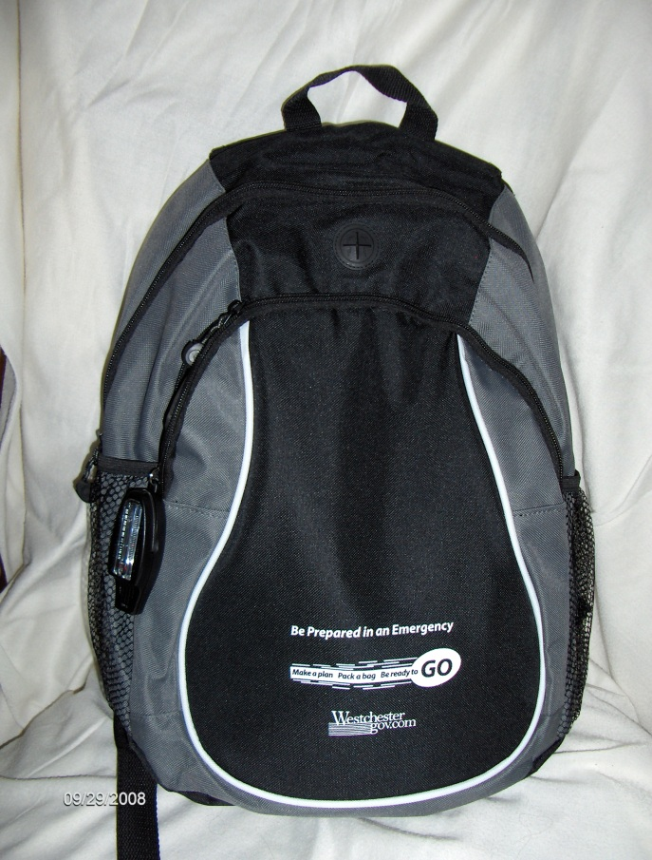

It is a good idea to put a few days worth of your prescription medications in your **Go-bag**. But if you take a lot of medication or your medication changes often, it may be easier to keep your medications together in one place, and then put them in your **Go-bag** when you must leave. You might want to put a reminder on the outside of your bag that says, “Take Meds.” It is also helpful to have copies of your prescriptions. If you do not have those, then use the medication information included on your ***Personal Emergency Plan*** to get more medicine if you need it.

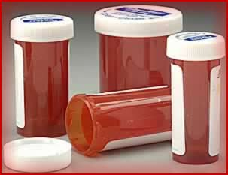 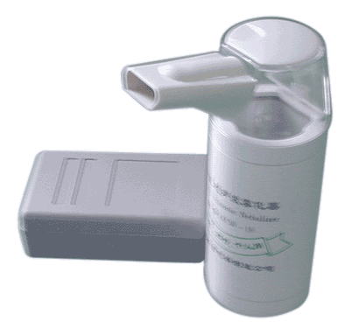

Put copies of important documents in your **Go-bag**. These might include birth certificates, medical insurance cards, health directives, and bank account information. See the ***Go-Bag Checklist*** for a complete list of documents.

**MCj04347130000[1]**Write down all documents on **Form H of *Personal Emergency Plan***. **BD21298_** Put all the documents in plastic bags to protect them.

Finally, put your ***Personal Emergency Plan*** inside your **Go-bag**. This way you will have all your necessary information and directions for first responders with you when you leave.

If you have a service animal or pet prepare another bag with supplies like food, water, bowl, leash, medications, and photo. Make sure your pet has an ID tag and up-to-date vaccinations.

***Go-bag Checklist***

Bottled water \_\_\_\_\_ Snacks \_\_\_\_\_ Comfort item \_\_\_\_\_\_\_\_\_\_\_\_\_\_\_\_\_\_

Medications \_\_\_\_\_ Copies of prescriptions, empty Rx bottles \_\_\_\_\_

Other medications: Pain killer \_\_\_\_ Antacid \_\_\_\_ Laxative \_\_\_ Other \_\_\_\_\_

Personal Items – small sized: Shampoo \_\_\_\_\_ Soap \_\_\_\_ Deodorant \_\_\_\_\_ Tissues \_\_\_\_\_Toothbrush \_\_\_\_\_ Toothpaste \_\_\_\_\_ Denture solution \_\_\_\_\_

Comb or brush \_\_\_\_\_Moist towelettes \_\_\_\_\_ Hand sanitizer \_\_\_\_\_

Sanitary supplies \_\_\_\_\_ Toilet paper \_\_\_\_Extra eyeglasses and case \_\_\_\_\_ Contact lens case and cleaner \_\_\_ Extra contact lens\_\_\_ Hearing aid batteries \_\_\_

Medical supplies: Catheters \_\_ Tubing \_\_ Syringes \_\_ Inhalator \_\_ Diabetes supplies \_\_\_ Mask \_\_\_Other \_\_\_\_\_\_\_\_\_\_\_\_\_\_\_\_\_\_\_\_\_\_\_\_\_\_\_\_\_\_

First Aid Kit: bandages, cleansing wipes, antiseptic

Extra set of clothes or underwear \_\_\_\_\_\_\_\_

Cash \_\_\_\_\_ ATM card \_\_\_\_\_ Credit card \_\_\_\_\_

Cell phone \_\_\_\_\_ Cell phone charger \_\_\_\_\_

Baby supplies (if needed) \_\_\_\_\_\_\_\_\_\_\_\_\_\_\_\_\_\_\_\_\_\_\_\_\_\_\_\_\_\_\_\_\_\_\_\_\_\_

**Important documents**: Photo ID \_\_\_\_\_ Copy of birth certificate \_\_\_\_\_ Copy of medical insurance cards \_\_\_\_ SSI/SSDI Award Letter \_\_\_\_\_\_\_\_ Health directives \_\_\_\_Proof of address \_\_\_ Home insurance information\_\_\_\_ Guardianship papers \_\_\_\_ Bank account numbers \_\_\_\_\_\_

***Personal Emergency Plan***– folder that includes medical information, contacts, daily living/mobility/ communication/emotional needs, escape plan, documents

***Things to Remember***

* An important part of being prepared for an emergency is to have the supplies you will need.
* You should have a **Basic Supplies Home Kit** that you keep in your home to use when you cannot leave your home.
* Include items in your home kit like food, water, personal and hygiene items, medical supplies, flashlight. Review your checklist.
* You should have a smaller kit or **Go-bag** that you can take with you if you have to leave your home for a few days. Review the checklist for the supplies to include.
* Make sure you include medications, copies of important documents, and your ***Personal Emergency Plan*** folder in your **Go-bag.**
* Keep your **Go-bag** in a place where you can get it quickly.
* Remember to take the **Go-bag** with you!

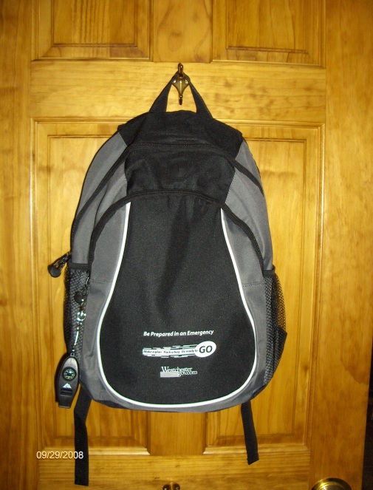

**Section 6: Fire Safety**

**Things we’ll do**

* Learn what to do to prevent a fire
* Talk about what to do in case of a fire
* Review how to draw an **Escape Plan**

**After this section I will**

* Know how to prevent a fire
* Know what to do in case of a fire
* Understand how to plan an escape route

**MCj04347130000[1]After this section I need to**

* Draw an **Escape Plan** and review it with my support persons
* Practice fire drills often

**Fire Safety**

**Fires** are emergency situations that can happen very suddenly. It is best to try and prevent fires in the first place. Some ways to do that are:

* Keep curtains and dishtowels away from stoves.
* Always watch food that is cooking on the stove.
* Watch your sleeves when you are cooking.
* Be sure your stove and small appliances are off before going to bed.
* Do not put too many plugs in electrical sockets.
* Never leave lit cigarettes around and never smoke in bed.
* Every home should have smoke alarms. If you are hearing impaired, get alarms that have flashing lights as well.
* Get rid of clutter.

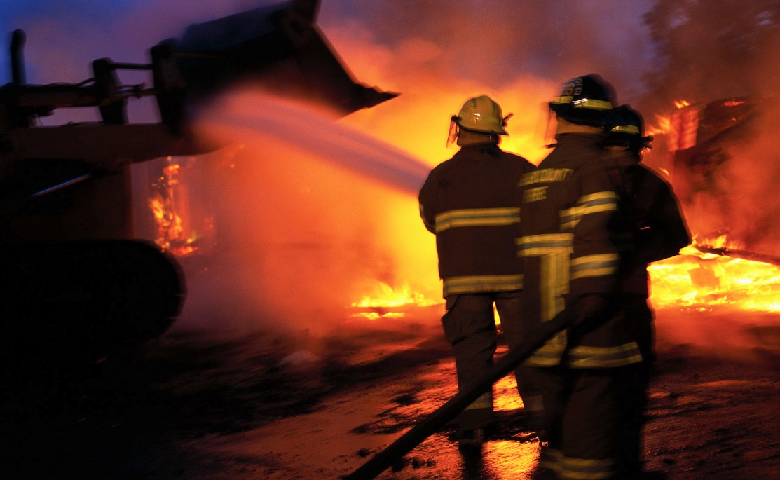

To be prepared in case of a fire you should **MCj04347130000[1]** draw a floor plan of your home on the **Escape Plan** form with **at least two ways out**. You can include windows along with doors as exits. Make sure that the windows are not nailed or painted shut. Learn how to remove the screen quickly and easily. If your windows have security bars, make sure they can be opened.

If you have a fire escape, make sure it works and that you know how to use it. Plan how you can escape from a second floor if the door is blocked. You may want to get a collapsible ladder. **MCj04347130000[1]** Discuss your escape routes with your support person. Plan with your support people where you will meet outside your home. Include the name of someone who can help you if needed. **MCj04347130000[1]**You can also get advice from your local fire department on making your escape plan.

Hang your **Escape Plan** in a place where you can see it easily.

**MCj04347130000[1]** Practice your escape route.

See the following example of a floor plan.

\*taken from American Red Cross/FEMA publication “Preparing for disaster for people with disabilities and other special needs.”

* **Go to Form F of Personal Emergency Plan BD21298_**

**What do you do in case of a fire?**

The most important thing to remember is to **get out fast**. You need to stay low to the floor since smoke rises during the fire. If you cannot keep low, try to keep your mouth covered. Look for the way out of the room. If a door is hot, do not open it. There may be fire on the other side of it. Try another way out. If you cannot walk and a wheelchair is not nearby (for example, if you are in bed) a support person may be able to drag you in a blanket. **MCj04347130000[1]**Discuss this ahead of time with your physician or therapist. If you cannot get out, put a cloth under the door to keep smoke out. Call 911. Signal rescuers at the window with a white cloth. If you catch fire, do not run. Stand still, drop to the floor, and roll over to put out the fire. If you use a wheelchair, lock the chair, drop to the floor, and roll over.

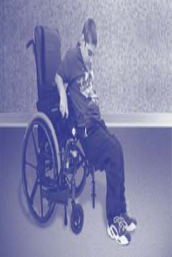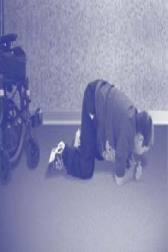

**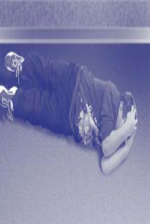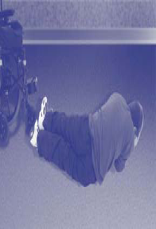**

**Lock, Drop, and Roll From Fire Safety for Children with Special needs Riley Hospital for Children**

**Remember: get out of your home fast. Drop ONLY IF you are on fire. Once you are outside, do not go back in for anything!**

***Things to Remember***

* Know how to prevent fires from starting.
* Know two ways out of your home. Draw this on your **Escape Plan**.
* Show your **Escape Plan** to your support people.
* Hang your **Escape Plan** in a place where you can see it easily.
* Practice fire drills often.
* In case of a fire **get out fast.**
* Go to meeting place.
* **Do not go back in house for anything!**

**Section 7: Review of What You Learned**

**Things we’ll do**

* Discuss the steps I take if I must leave my home
* Review what to do if I must stay in my home during an emergency
* Review my ***Personal Emergency Plan***
* Discuss importance of sharing information and keeping up-to-date
* Answer the questions on ***Things to Review***

**After this section I will**

* Know what steps I need to take in an emergency
* Understand how my ***Personal Emergency Plan*** will help me
* Have a complete ***Personal Emergency Plan***
* Be prepared for any emergency

**MCj04347130000[1]After this section I need to**

* Review my ***Personal Emergency Plan*** with my support people
* Remember to review my plan every few months
* Replace food and water every six months

**What have you learned?**

You learned how to prepare for emergencies and what to do during an emergency. You learned that you prepare by getting supplies and documents together. You also prepare by making your own ***Personal Emergency Plan*.** This plan includes information about you and about what you should do in an emergency.

Review the following sections on what to do in an emergency and how to use your ***Personal Emergency Plan***. You can see how much you remember of this program by answering the questions on ***Things to Review***. You can also look at the ***Things to Do*** list to make sure that you have done everything you need to be prepared for an emergency.

**What do you do if you must leave your home for a few days?**

There are a number of steps to remember if you must leave your home.

1. Contact the support people who can help you out.
2. Arrange for transportation.
3. Let others know how they can best assist you. This should be written in your ***Personal Emergency Plan***.
4. Take your **Go-bag**.
5. Take your ***Personal Emergency Plan***, which contains all your necessary information.
6. Meet support people at the place written in your plan.
7. Stay calm.

These steps are written on the **Steps in an Emergency** (**Form G**) section of your ***Personal Emergency Plan***.

**What do you do when you cannot leave your home?**

There may be a time when you cannot leave your home. An example is during a hurricane or snow storm. You may not have electricity. You should have your **Basic Supply Home Kit** nearby and your list of support people in your ***Personal Emergency Plan***. In order to be safe, you must remember what you learned in the first section of this program. For example, during a hurricane you must stay away from the windows. Listen to your radio or TV to get information about the emergency. Call one of your support people to get more information. Have someone come over if you are feeling frightened or nervous.

Have your ***Personal Emergency Plan*** close by in case you have to show the information to anyone who comes to help you.

**Using your Personal Emergency Plan**

Your ***Personal Emergency Plan*** includes the following sections:

* Medical Information
* Immunizations and Medications
* Daily Living/Mobility Needs
* Communication/Emotional Needs
* Contact Information
* Escape Plan (floor plan)
* Steps in an Emergency
* My Documents

You may need to show parts of your plan to someone **right away**. For example, on the **Communication/Emotional Needs** section there is a space that explains how you might feel during an emergency and how someone can make you feel calm. If so, keep that section right up front in the folder. Other sections will let others know how they can help you if you are evacuated to another place for a few days.

Hang the **Escape Plan** and the **Steps in an Emergency** form in a place where you can see them quickly and easily. Keep a copy of **My Health Summary** with you at all times. Put the rest of the forms in a folder.

Arrange your ***Personal Emergency Plan*** folder in the way that is most helpful to you. The sample may help you. The most important thing is that you have it complete and that you remember to have it nearby when you are home or bring it with you if you must leave!

**MCj04347130000[1]** It is important to review your plan with your support people every few months. Have your Service Coordinator also go over every time you review your Individualized Service Plan. Some information may need to be updated, like medications and immunizations. Your **Basic Supplies Home Kit** and **Go-bag** should be checked every few months. Make sure that your food and water are still good. Check expiration dates.

**Remember: keep your *Personal Emergency Plan* folder in your Go-bag so you have it with you in an emergency**.

Congratulations…Now that you have completed your ***Personal Emergency Plan***, you have taken **Responsibility** for your **Safety** and are prepared for any emergency that may happen!

***Things to Review***

The following questions cover all the areas of this training. See how much you remember. If you cannot answer a question, read it over again. Keep this information handy. Review it often.

1. What is an *emergency*?
2. What does *evacuate* mean? What does *shelter-in-place* mean?
3. What is a *first responder*?
4. What happens during a winter storm?
5. What should you do during a winter storm?
6. What are some things you should **not** do when there is lightning?
7. What happens during a hurricane and a tornado?
8. Where should you go in your home during a hurricane? A tornado?
9. What should you do if you feel the ground shaking?

10. What should you remember if you must leave your house during a flood?

11. What should you do and **not** do during a heat wave?

12. What are some items you should have during a blackout?

13. Who are your support people?

14. What do you need to tell your support people?

15. What transportation will you use if you must leave your home?

16. How will you communicate with your support people?

17. How will you know there is an emergency?

18. What are some things you should have in your home in case you cannot leave for a few days?

19. What are some of the items you should put in your go-bag?

20. What written information should be included in your ***Personal Emergency Plan***?

21. What important documents (copies) should you include in your ***Personal Emergency Plan***?

22. What should you do to prevent a fire in your home?

23. What should you do to prepare ahead in case of a fire?

24. What are the important things you must remember in case there is a fire in your home?

25. What are the steps you should take when you must leave your home for a few days?

26. What should you do if you must stay in your home?

|  |  |  |  |
| --- | --- | --- | --- |
|  | **Check**  **when Completed** | | |
|  | Get information on medical history, immunizations, medications | \_\_\_\_\_\_\_ |
|  | Get information on any medical or communication devices, daily living devices, mobility devices or special vehicles I use \_\_\_\_\_\_ | \_\_\_\_\_\_\_ |
|  | Contact utilities company if needed\_\_\_\_\_\_\_\_\_\_\_\_\_\_\_\_\_\_\_\_\_\_\_ | \_\_\_\_\_\_\_ |
|  | Learn how to shut off utilities \_\_\_\_\_\_\_\_\_\_\_\_\_\_\_\_\_\_\_\_\_\_\_\_\_\_\_ | \_\_\_\_\_\_\_ |
|  | Discuss how I might feel during an emergency with my family, friends, or support persons \_\_\_\_\_\_\_\_\_\_\_\_\_\_\_\_\_\_\_\_\_\_\_\_\_\_\_\_\_ | \_\_\_\_\_\_\_ |
|  | Complete the **Medical History,** **Immunizations**, **Medications, Daily Living/Mobility Needs, Communication** sections of my ***Personal Emergency Plan*** \_\_\_\_\_\_\_\_\_\_\_\_\_\_\_\_\_\_\_\_\_\_\_\_\_\_\_\_\_\_ | \_\_\_\_\_\_\_ |
|  | Get photo ID\_\_\_\_\_\_\_\_\_\_\_\_\_\_\_\_\_\_\_\_\_\_\_\_\_\_\_\_\_\_\_\_\_\_\_\_\_\_\_\_\_\_ |  |
|  | Call town hall or fire department to let them know my needs \_\_\_ | \_\_\_\_\_\_\_ |
|  | Talk to each of my support people about how they can help me | \_\_\_\_\_\_\_ |
|  | Show support people how to use any equipment I need \_\_\_\_\_\_\_ | \_\_\_\_\_\_\_ |
|  | Discuss transportation and evacuation plan with support people |  |
|  | Give at least one support person the key to my home \_\_\_\_\_\_\_\_ | \_\_\_\_\_\_\_ |
|  | Sign up for a local registry \_\_\_\_\_\_\_\_\_\_\_\_\_\_\_\_\_\_\_\_\_\_\_\_\_\_\_\_\_\_ | \_\_\_\_\_\_\_ |
|  | Complete **Contact Information** and **Steps in an Emergency** sections of my ***Personal Emergency Plan*** \_\_\_\_\_\_\_\_\_\_\_\_\_\_\_\_ | \_\_\_\_\_\_\_ |
|  | Start getting items for **Basic Supplies Home Kit** and **Go-bag** | \_\_\_\_\_\_\_ |
|  | Make copies of my important documents to include in my ***Personal Emergency Plan*** folder\_\_\_\_\_\_\_\_\_\_\_\_\_\_\_\_\_\_\_\_\_\_\_\_ | \_\_\_\_\_\_\_ |
|  | Draw **Escape Plan** \_\_\_\_\_\_\_\_\_\_\_\_\_\_\_\_\_\_\_\_\_\_\_\_\_\_\_\_\_\_\_\_\_\_\_\_ | \_\_\_\_\_\_\_ |
|  | Review **Steps in an Emergency** with support people \_\_\_\_\_\_\_ | \_\_\_\_\_\_\_ |
|  | Decide where to put **Steps in an Emergency** sheet so I can see it right away\_\_\_\_\_\_\_\_\_\_\_\_\_\_\_\_\_\_\_\_\_\_\_\_\_\_\_\_\_\_\_\_\_\_\_ | \_\_\_\_\_\_\_ |
|  | Finish putting together **Basic Supplies Home Kit** and **Go-Bag** | \_\_\_\_\_\_\_ |
|  | Complete my ***Personal Emergency Plan*** \_\_\_\_\_\_\_\_\_\_\_\_\_\_\_\_\_ | \_\_\_\_\_\_\_ |

***Things to Do***

**References and Resources**

Information for the curriculum was based on the principles of emergency preparedness set by **FEMA(**[**www.fema.gov**](http://www.fema.gov)**), (**[**www.ready.gov**](http://www.ready.gov)**) , the Department of Homeland Security (**[**www.dhs.gov**](http://www.dhs.gov)**), the American Red Cross (**[**www.redcross.org**](http://www.redcross.org)**),** and **the U.S. Fire Administration (**[**www.usfa.dhs.gov**](http://www.usfa.dhs.gov)**),**  in particular the following publications:

American Red Cross. ***Disaster preparedness for people with disabilities***. Retrieved from <http://www.redcross.org/www-files/Documents/pdf/Preparedness/Fast%20Facts/Disaster_Preparedness_for_PwD-English.pdf>

American Red Cross and FEMA. (2004, August) ***Preparing for disaster for people with disabilities and other special needs***. Retrieved from <http://www.redcross.org/www-files/Documents/Preparing/A4497.pdf>

Department of Homeland Security. ***Preparing makes sense for people with disabilities and special needs***. Retrieved from <http://www.ready.gov/america/_downloads/disabilities.pdf>

Department of Homeland Security. (1999, December). ***Fire risks for the mobility impaired****.* Retrieved from <http://www.usfa.dhs.gov/downloads/pdf/publications/fa-204-508.pdf>

Federal Emergency Management Agency (FEMA). (2009, June 4). ***Are you ready? An in-depth guide to citizen preparedness*.** Retrieved from <http://www.fema.gov/areyouready/index.shtm>

U.S. Fire Administration. ***Learn about fire escape plans***. (2009, October). Retrieved from <http://www.usfa.dhs.gov/campaigns/smokealarms/escapeplans/index.shtm>

**Additional resources include the following:**

Center for Disability and Special Needs Preparedness. (2007). ***Disaster readiness planning template for providers of services to people with disabilities or other special needs****.* Retrieved from <http://www.disabilitypreparedness.org>.

Connecticut Department of Public Health. (2007).***Tips for people with cognitive disabilities*, *Tips for special needs of medically fragile people,* and *Creating an******emergency health information card***. Retrieved from http://[www.ct.gov/dph](http://www.ct.gov/dph). (Go to Public Health Preparedness and Response and then Preparing Your Loved Ones: People with Special Needs.)

De La Garza, Denise. (2007) ***Good to go: hurricane evacuation kit****.* Texas Center for Disability Studies Austin Texas. Retrieved from <http://tcds.edb.utexas,edu>.

Family Voices. ***Emergencies and disasters: keeping children and youth with special health care needs safe****.* Retrieved from <http://www.familyvoices.org/info/emergencies.php>.

Independent Living Resource Center San Francisco in cooperation with June Kailes, Disability Consultant, through a grant from The American Red Cross Northern California Disaster Preparedness Network. (2006). ***Prepare.org: tips for people with cognitive disabilities****.* Retrieved from <http://www.redcross.org/museum/prepare_org/disabilities/cognitivetips.htm>

Lamar University. ***Disaster preparedness planning packet for special needs populations***. Retrieved from <http://dept.lamar.edu/nursing/specialneeds/final.pdf>.

National Organization on Disability. (2010). ***Prepare yourself: disaster readiness tips for people with developmental or cognitive disabilities****.* Retrieved from [www.nod.org/emergency](http://www.nod.org/emergency).

New York State OMRDD. (2007, Summer). ***Disaster planning and the role of the service coordinator***. Medicaid Service Coordination Technical Bulletin, 11, pp.1-3. Retrieved from <http://www.omr.state.ny.us/wt/publications/wt_msc_tb_11.pdf>

Office of Emergency Management, County of Los Angeles. (2006, June). ***Emergency preparedness: taking responsibility for your safety: tips for people with disabilities and activity limitations***. Retrieved from [www.espfocus.org](http://www.espfocus.org).

Riley Hospital for Children, Community Education and Child Advocacy Department. ***Fire safety for children with special needs****.* Retrieved from [www.rileyhospital.org/kids1st](http://www.rileyhospital.org/kids1st).

Sesame Street, (2008, July). ***Let’s get ready! Planning together for emergencies****.* Retrieved from <http://www.sesamestreet.org/ready/plan>.

Westchester Disability Advocacy Partnership. (2009).***Take control: guide to preparing for emergencies for parents of children with special needs***. White Plains, NY: Independent Living Center.

**Webinars, Courses, Presentations**:

Garrett, Andrew L., MD, MPH. (2008, May). ***Preparedness issues for children with special health care needs***. Power Point Presentation retrieved from National Center for Disaster Preparedness, Mailman School of Public Health, Columbia University, <http://www.ncdp.mailman.columbia.edu>.

Kailes, June Isaacson. (2007, November). ***Disaster lights and disaster heavies: relevant emergency preparedness information for people with disabilities***. Webinar retrieved from [www.jik.com](http://www.jik.com).

Kailes, June Isaacson. (2009, August). ***Emergency registries for evacuating and/ or assisting people with disabilities and activity limitations – an effective tool or false expectations- where are we?*** Webinar retrieved from www.aucd.org.

***Ready, willing, and able****.* (2008). Training course retrieved from Research and Training Center on Independent Living, University of Kansas, <http://ks.train.org>.

**Name:** Lee Smith **Date of Birth:** 2/14/78

***SAMPLE***

Form A

**Address:** 34 Oak Street, Valhalla, NY 10532

**Phone Number:** 914-552-5553

**Social Security Number:** 123-12-1234

**Contact Person or Guardian /Phone Number:** Mary Jones,

914-333-3333

**Agency providing services:** Able Agency, 914 332-2222

**Medical Information**

**Primary Physician:** Dr. Michael Brown **Phone Number:** 914-777-7777 **Fax** 914-777-7722

**Address:** 12 Main St., Yonkers, NY 10332

**Medicaid Number:** DR12345M

**Medicare Number:** 1234567A

**Private Insurance:** Aetna **Policy Number:** 345678JKL

**Hospital:** Westchester Medical Center, Valhalla, NY

**Pharmacy:** Health Pharmacy, **Phone Number:** 914-888-8888 **Fax** 914-888-8866

**address:**  White Plains, NY

**Blood Type:** B positive

**Medical Conditions:**  Diabetes, Asthma, Arthritis in knee

**Regular Medical Treatments:**

Check blood sugar level daily, Use nebulizer when wheezing, physical therapy exercises for knee 3 times a week

**Allergies and Sensitivities/Reactions:**

Milk and dairy products, causes wheezing

**Special Diet:** No dairyfoods

**Medical Devices Needed:**

**Type Vendor/Contact Phone Number Batteries? Electricity?**

Glucometer & Strips ABCDiabetes 212-555-2222 No No

**Type Vendor/Contact Phone Number Batteries? Electricity?**

Nebulizer MedEquip 212-333-2232 No Yes

**People who know how to work device:** Mary Jones and John Smith

\_\_\_\_\_\_\_\_\_\_\_\_\_\_\_\_\_\_\_\_\_\_\_\_\_\_\_\_\_\_\_\_\_\_\_\_\_\_\_\_\_\_\_\_\_\_\_\_\_\_\_\_\_\_\_\_\_\_\_\_\_\_\_ \_\_\_\_\_\_\_\_\_\_\_\_\_\_\_\_\_\_\_\_\_\_\_\_\_\_\_\_\_\_\_\_\_\_\_\_\_\_\_\_\_\_\_\_\_\_\_\_\_\_\_\_\_\_\_\_\_\_\_\_\_\_\_\_\_\_\_\_\_\_\_\_\_\_\_\_\_\_\_\_

**Name:** Lee Smith **Date of Birth:** 2/14/78

***SAMPLE***

Form B1

**Address:** 34 Oak Street, Valhalla, NY 10532

**Phone Number:** 914-552-5553

**Contact Person or Guardian /Phone Number:** Mary Jones,

914-333-3333

**Agency providing services:** Able Agency, 914 332-2222

**Immunizations**

**Type Dates**

**Recent:**

PPD (Mantoux) 4/10/06, 4/24/07, 4/13/08 Negative

Influenza 10/09/06, 11/02/07, 10/23/08 Tetanus, Diphtheria (TD) 10/30/91, 6/10/01

T-pap 6/23/08

**Past:**

DTP 8/31/78, 10/20/78, 11/24/78, 1/12/78, 8/24/83

OPV 8/31/78, 10/20/78, 11/24/78 1/12/79, 8/24/83

Measles Mumps Rubella (MMR) 10/13/79, 10/17/91:

Tine 4/8/80, 12/3/80, 1/20/82, 12/83, 11/8/91 Negative.

Hepatitis B. 6/2/93, 8/9/93, 12/16/93. Blood test on 1/27/97 shows immunity

**Medications**

**Check:**

Medications are taken by me. \_\_X\_\_ Medications are given to me by someone else. \_\_\_\_

**Pharmacy Name** \_ Health Drugs \_\_\_\_\_\_**Phone number** \_\_\_999-9999\_\_\_\_\_\_\_\_\_\_\_\_

**Name/Dosage How Much How Often When Taken How Taken**

Glipizide20mg.1 tablet once a day morning with food

**Doctor Name on label:** Dr. Lopez, 914 -553-2223

**Check if needs refrigeration:**

**Name/Dosage How Much How Often When Taken How Taken**

**Doctor Name on label:**

**Check if needs refrigeration:**

**Name/Dosage How Much How Often When Taken How Taken**

**Doctor Name on label:**

**Check if needs refrigeration:**

**Name:** Lee Smith

***SAMPLE***

Form B2

**Medications - Continued**

Pharmacy Name \_\_Health Drugs\_\_\_\_\_\_\_ Phone Number \_\_\_999-9999\_\_\_\_\_\_

**Name/Dosage How Much How Often When Taken How Taken**

Synthroid .05 mg. 1 tab 2 times a day morning & evening before meal

**Doctor Name on label:** Dr. Lopez, 914 -553-2223

**Check if needs refrigeration:**

**Name/Dosage How Much How Often When Taken How Taken**

**Doctor Name on label:**

**Check if needs refrigeration:**

**Name/Dosage How Much How Often When Taken How Taken**

**Doctor Name on label:**

**Check if needs refrigeration:**

**Name/Dosage How Much How Often When Taken How Taken**

**Doctor Name on label:**

**Check if needs refrigeration \_\_\_\_\_\_\_\_**

**Name/Dosage How Much How Often When Taken How Taken**

**Doctor Name on label:**

**Check if needs refrigeration:**

**Name:** Lee Smith

Form C

***SAMPLE***

**Daily Living / Mobility Needs**

**Mobility Equipment Needed:**

**Type Vendor Phone Number Batteries? Electricity?**

Motorized wheelchair MobilityInc. 914 567-5678 Yes (back-up) Yes

**Type Vendor Phone Number Batteries? Electricity?**

**People who know how to work equipment:** Mary Jones and John Smith

**Daily living equipment needed:**

**Type Vendor Phone Number Batteries? Electricity?**

Hoyer liftMobilityInc. 914 567-5678 Yes (back-up) Yes

**Type Vendor Phone Number Batteries? Electricity?**

**People who know how to work equipment:** Mary Jones and John Smith

**I have a service animal named** Pepper  **who must stay with me.**

**License or ID Number:** 303KLM

**Vaccinations:** Rabies, 3/19/09

**I have a service animal named** Pepper  **who must stay with me.**

**I need HELP with:**

Getting on and off the toilet,

Getting in the bathtub, washing my back.

Brushing my teeth.

**SAFETY PRECAUTIONS**

I am unsteady without a walker and need assistance.

In an emergency I may need to be carried.

**To HELP me eat, I need:**

My food must be chopped up, I can’t chew well. I must use a spoon.

**I have a service animal named** Pepper  **who must stay with me.**

**License or ID Number:** 303KLM

**Vaccinations:** Rabies, 3/19/09

**\_\_\_**

***SAMPLE***

Form D

**Name:** Lee Smith

**Communication/ Emotional Needs**

**I need to bring \_\_\_**my photo album**\_\_\_\_\_\_\_\_\_\_\_\_\_with me to help me feel better.**

**To help CALM me, I would like a first responder to:**

Speak slowly and calmly. Use simple sentences.

Give me directions step-by-step.

Do not push me; take me gently by the arm.

Do not leave me alone.

**During an emergency I may FEEL or ACT:**

I get upset when I am rushed and I may not want to move.

When I am upset I may not be able to understand what you are saying.

I get confused when I feel stressed and I may try to run away.

**I understand \_\_**English**\_\_\_\_\_\_\_\_\_\_I can read words \_\_\_ pictures \_\_\_ Braille \_\_\_**

**I use sign language \_\_\_\_\_\_\_\_ I use hand/head movements \_\_\_\_**X**\_\_**

**I use a Communication Device:**

**Type:** Bluebird II

**Vendor Name/Phone:** MedEquip 212-333-2232

**Batteries/Electricity:** rechargeable batteries; also AC backup

**I have a hearing problem** yes **I have a visual impairment** no

**I wear eyeglasses \_\_\_ contact lenses \_\_\_ hearing aids \_\_**x**\_ dentures \_\_\_\_**

**Contact Information**

***SAMPLE***

Form E

**Name:** Lee Smith **Date of Birth:** 2/14/78

**Address:** 34 Oak Street, Valhalla, NY 10532

**Phone Number:** 914-552-5553

**Social Security Number:** 123-12-1234

**Agency providing services:** Able Agency, 914 332-2222

**Contact Person:** Mary Jones

**Phone Number:** 914-333-3333, 914 556-7890 cell

**E-mail address:**  jonesm@gmail.com

**Address:** 145 Main Street, Hartsdale, NY 10333

**Out-of-state Contact:** Ed Black

**Phone Number:** 215-554-4444

**E-mail address:** eblack@gmail.com

**Address:** 13 High Street, New Hope, PA 19111

**Support Persons**

**Name:** Jose Gomez

**Location:** Able Day Hab program, White Plains, NY

**Phone Number:** 914-557-7654 **E-mail address:** jgomez@able.org

**Name:** Fred White

**Location:** 34 Oak Street, Valhalla, NY (upstairs neighbor)

**Phone Number:** 914 -665-8976 **E-mail address:** none

**Name:** Jean John, asst. manager

**Location:** ShopRite, Hartsdale, NY

**Phone Number:** 914-668-3333 **E-mail address:** jj@shoprite.com

**Name:** Tanya Smith, Recreation Supervisor

**Location:** White Plains Bowling

**Phone Number:** 914-998-9999 **E-mail address:** ts@wprec.org

**Name:** Lee Smith

Form F

***SAMPLE***

**Escape Plan**



**Where I will meet outside my home:** By the large oak tree

**Who will help me:** Fred White – upstairs neighbor

\* Sample taken from American Red Cross/FEMA publication “Preparing for disaster for people with disabilities and other special needs.”

**STEPS IN AN EMERGENCY**

***SAMPLE***

Form G

**This sheet tells you what you must do if you have to leave your home. Do not use it if there is a fire in your home.**

**In case of fire, GET OUT FAST!**

1. **I will know there is an emergency because:**

Mary Jones will call me on my phone.

The county will call me.

I will hear it on the radio.

1. **I will call (contact/support person):**

My upstairs neighbor, Fred White 914 -665-8976

My contact, Mary Jones, 914-333-3333

1. **For transportation I will call:**

Ambulette Services, 914 -557-1234

My friend Jose who has a car, 914-552-5252

1. **Let others know how they can help me.**

I am unsteady without a walker and need assistance.

In an emergency I may need to be carried.

I get upset when I am rushed and I may not want to move.

When I am upset I may not be able to understand what you are saying.

I get confused when I feel stressed and I may try to run away.

1. **Take Go-Bag with *Personal Emergency Plan* folder in it.**
2. **Go to:** Aunt Rosie’s house - 123 Spring Street, Greenwich, Ct.
3. **Call out-of-area contact:** Ed Black,215-554-4444

(E-mail address):eblack@gmail.com

**IF I AM HURT**

**I WILL CALL 911**

***SAMPLE***

Form H

**My Documents**

**The following copies of documents are enclosed:**

**1.** my birth certificate

**2.** Medicaid card, Blue Cross card

**3.** letter about my SSI

**4.** my Health Care proxy

**5.** my bank account statement