Go-bag Checklist 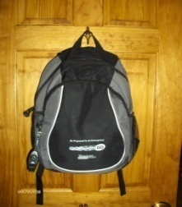
These are items you should take if you must leave your home quickly. Most of them can be kept in a Go-bag ahead of time so you are ready to go when you must leave.
_ Bottled water _ Snacks 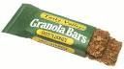 _ Cash

_ Medications and medical supplies 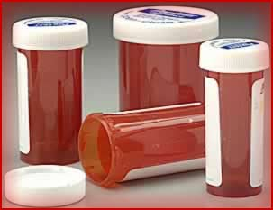 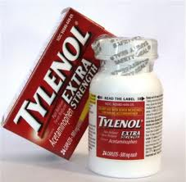 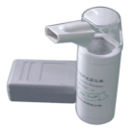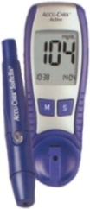

_ Copies of prescriptions
Personal items - small sized: _ Toothbrush _ Toothpaste 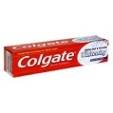 _ Shampoo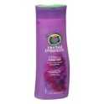

_ Hand sanitizer 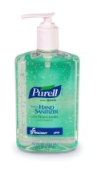 _ Body wipes _ Deodorant _ Sanitary items

_ Contact lens case & cleaner 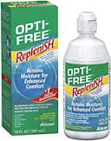 _ Denture case & cleaner

_ Eyeglasses & case 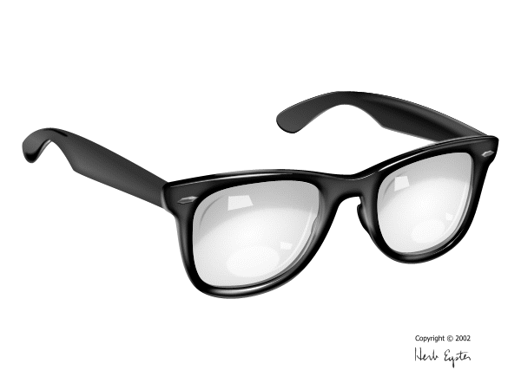 _ Hearing aid batteries 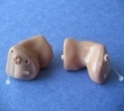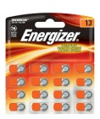_ Comb or brush

_ Cell phone & charger 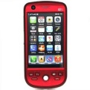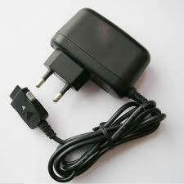 _ Extra batteries or chargers for electronic devices
_ First aid Kit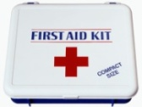 _ Leisure item (book, iPod) _ Extra clothes or underwear

Include your Personal Emergency Plan in your Go-Bag.
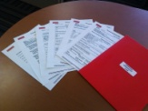
Personal Emergency Plan
It is a folder with important forms: Health Information; Contacts; Daily living, Mobility, Communication & Emotional Needs; Photos; Documents as needed (list below):
** Forms can be found at www.wihd.org Resource Library Training Curricula
Important documents to include:
Copy of birth certificate ___
Photo ID ___ Photo of service animal ___
Copy of medical insurance cards ___ Medical documents ___
SSI/SSDI Award Letter ___
Health directives/Health care proxy ___
Guardianship papers ___
Proof of address (from utility bill or license) ___
Home insurance information___
Bank account numbers ___
** Service animals should have separate Go-Bag.

