***Basic Supplies Home Checklist***

Make sure you have enough of these supplies in your home to last three or more days in case you cannot leave and you have no electricity.

* Water: one gallon for each day per person [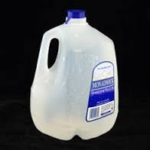](http://www.google.com/imgres?imgurl=http://3.bp.blogspot.com/-UXc8k7WWvys/ThvMrXEPEMI/AAAAAAAAAb4/M-wzWBy66Yk/s1600/monadnock_gallon_water.jpg&imgrefurl=http://krenncrew.blogspot.com/2011/07/fyi.html&h=245&w=245&sz=32&tbnid=Bb26uxr98aRVXM:&tbnh=100&tbnw=100&prev=/search?q=photo+of+water+gallon&tbm=isch&tbo=u&zoom=1&q=photo+of+water+gallon&usg=__PNnEu4iPOCJCBDE5Bgx7GPH4hf0=&docid=Bq997gKQkfTpJM&sa=X&ei=0FrMUanDEerA4AOB-oDwAw&ved=0CDsQ9QEwBQ)
* Food that does not need refrigeration or heat

[](http://www.google.com/imgres?imgurl=http://www.wpclipart.com/food/desserts_snacks/granola_bar_picture.png&imgrefurl=http://www.wpclipart.com/food/desserts_snacks/granola_bar_picture.png.html&h=249&w=440&sz=43&tbnid=NuyfHM7BSscs9M:&tbnh=71&tbnw=125&prev=/search?q=photo+of+granola+bar&tbm=isch&tbo=u&zoom=1&q=photo+of+granola+bar&usg=__ZOeXs3Zcr7WckdmKI4-oRdSX_zg=&docid=UdFqcEDEwWS7AM&sa=X&ei=RnTMUbiuMtep4AOutIHgDg&ved=0CE8Q9QEwAw) [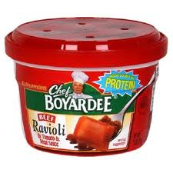](http://www.google.com/imgres?imgurl=http://11andrew.edublogs.org/files/2010/02/chef-boyardee.jpg&imgrefurl=http://11andrew.edublogs.org/2010/02/18/ettore-boiardi/&h=500&w=500&sz=45&tbnid=y771BecXFGXMyM:&tbnh=99&tbnw=99&prev=/search?q=photo+of+chef+boyardee&tbm=isch&tbo=u&zoom=1&q=photo+of+chef+boyardee&usg=__l6cm2NjsjZzKdEWbuX3YO8ZMZ7w=&docid=1yVHRvO_Ugkw1M&sa=X&ei=pHTMUY_RKJfk4AO15oGYAQ&ved=0CFgQ9QEwDg)[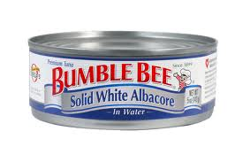](http://www.google.com/imgres?imgurl=http://www.bumblebee.com/images/products/ProductImages/542a9b09-c471-4a00-aa0f-e1ac902e66ea.gif&imgrefurl=http://www.grubstreet.com/2013/03/bumble-bee-tuna-recall.html&h=600&w=900&sz=131&tbnid=oftxxedniQS_XM:&tbnh=70&tbnw=105&prev=/search?q=photo+of+canned+tuna+fish&tbm=isch&tbo=u&zoom=1&q=photo+of+canned+tuna+fish&usg=__tfuJCA2ly9iHEGScpGhd2AuZCHM=&docid=e8V-PoXgYq7jtM&sa=X&ei=j1rMUYLQEcHi4AOy-YCICQ&ved=0CEwQ9QEwCg) Manual can opener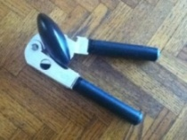

* Medications and Medical Devices

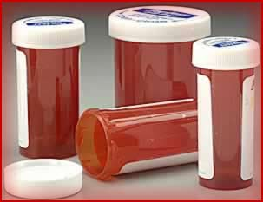 [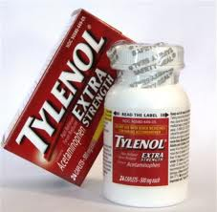](http://www.google.com/imgres?imgurl=http://l.yimg.com/ck/image/A8323/832398/300_832398.jpg&imgrefurl=http://voices.yahoo.com/3-over-counter-drugs-not-as-safe-as-think-4927744.html&h=294&w=300&sz=36&tbnid=r5wefOpT_w-lvM:&tbnh=114&tbnw=116&prev=/search?q=photo+of+over+the+counter+drugs&tbm=isch&tbo=u&zoom=1&q=photo+of+over+the+counter+drugs&usg=__d0GKYbweqCIzh2AJu4yWGbXlnSs=&docid=0piBtAyeiLbWBM&sa=X&ei=yXbMUdikE9Oo4APdtIGICA&ved=0CF8Q9QEwEA&dur=40) 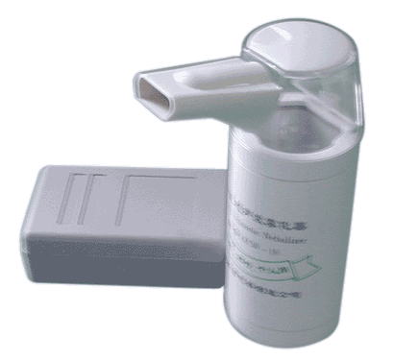 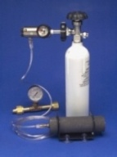 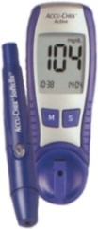 

* Flashlight with batteries or wind-up, Wind-up radio, Extra batteries

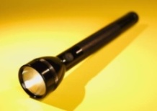 [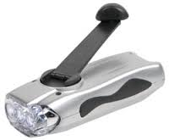](http://www.google.com/imgres?imgurl=http://www.abilityanswers.com/images/3%20LED%20WIND-UP%20FLASHLIGHT.jpg&imgrefurl=http://www.abilityanswers.com/3-led-wind-up-flashlight-pack-of-2-p-1856.html&h=207&w=250&sz=9&tbnid=NDMjDwgOOX8nTM:&tbnh=83&tbnw=100&prev=/search?q=photo+of+wind+up+flashlight&tbm=isch&tbo=u&zoom=1&q=photo+of+wind+up+flashlight&usg=__fciPZYvyjLRFaJxSRiwRdOOwexg=&docid=W_5Sc87-ZxmhaM&sa=X&ei=XmrMUcHDD7iw4AP91YCwBQ&ved=0CD8Q9QEwBg&dur=826) 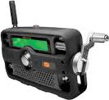 [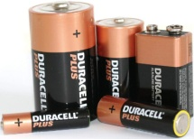](http://www.google.com/url?sa=i&rct=j&q=photo+of+batteries&source=images&cd=&cad=rja&docid=Va-UllElKKm5tM&tbnid=S6Sce5-yoUboKM:&ved=0CAUQjRw&url=http://sindh.all.biz/alkaline-batteries-g5143&ei=s33MUej3J8b94AOI0YGQCA&bvm=bv.48572450,d.dmg&psig=AFQjCNG5nFvevcD7XxA-nXbgT_vOTJS8lw&ust=1372442362836140) [](http://www.google.com/url?sa=i&rct=j&q=back-up+batteries+for+wheelchairs&source=images&cd=&cad=rja&docid=TmwLqhvamQ3GEM&tbnid=KUrfl4Z9wVuw-M:&ved=0CAUQjRw&url=http://www.tcwtech.com/IBBS.htm&ei=53_MUeGOL8Pc4AP-rIC4Aw&bvm=bv.48572450,d.dmg&psig=AFQjCNGmQ59zGSGQAqEC4qekSmV7AAws0g&ust=1372442672883875)

* Back-up Batteries for all devices and equipment, including wheelchairs
* Personal Hygiene items: shampoo, soap, toothpaste, deodorant, others

[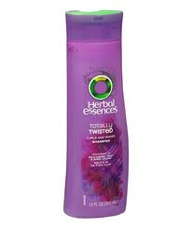](http://www.google.com/imgres?imgurl=http://img4-2.realsimple.timeinc.net/images/1202/totally-twisted-shampoo_300.jpg&imgrefurl=http://www.realsimple.com/magazine-more/inside-magazine/road-tests/best-shampoos-00000000022809/page6.html&h=357&w=300&sz=26&tbnid=ULX7lRUKBtO5-M:&tbnh=93&tbnw=78&prev=/search?q=photo+of+shampoo&tbm=isch&tbo=u&zoom=1&q=photo+of+shampoo&usg=__es1axIylxE1h2Fd6ee7Z-tQ9Pzk=&docid=kC60VgTTvgWfrM&sa=X&ei=6lbMUYLEB_Wn4APsx4BI&ved=0CEUQ9QEwCA) [](http://www.google.com/imgres?imgurl=http://upload.wikimedia.org/wikipedia/commons/7/74/Soap_in_blue_dish.JPG&imgrefurl=http://www.eflnet.com/vocab/wordlists/noun_list/soap&h=1024&w=1365&sz=186&tbnid=LdSpLM5DsrX5DM:&tbnh=88&tbnw=117&prev=/search?q=photo+of+soap&tbm=isch&tbo=u&zoom=1&q=photo+of+soap&usg=__NnuRDoig9qpPzc-7zbVdrky7rVI=&docid=aicDFGLbNyk9wM&sa=X&ei=OVXMUZbSObK14AORioB4&ved=0CCwQ9QEwAA) [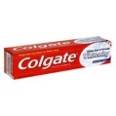](http://www.google.com/imgres?imgurl=http://blogs.dickinson.edu/mindmeetsmatter/files/2010/11/colgate-tooth-whitening-paste.jpg&imgrefurl=http://blogs.dickinson.edu/mindmeetsmatter/category/nanotechnology-toothpaste/&h=280&w=280&sz=7&tbnid=pNK3DUUh_kiptM:&tbnh=88&tbnw=88&prev=/search?q=photo+of+toothpaste&tbm=isch&tbo=u&zoom=1&q=photo+of+toothpaste&usg=__3sv_q1BAcpczy30xajqpNZb00_E=&docid=feCQayeVxM4P0M&sa=X&ei=6FfMUb7bLM-44AP5yIDwAQ&ved=0CHEQ9QEwDg&dur=2105) [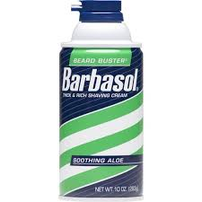](http://www.google.com/imgres?q=photo+shaving+cream&biw=1920&bih=985&tbm=isch&tbnid=YBKqbGCZZ57MeM:&imgrefurl=http://www.walmart.com/ip/Barbasol-Aloe-Shave-Cream-10-oz/17619758&docid=EgV19d-tsasI9M&imgurl=http://i.walmartimages.com/i/p/00/05/10/09/00/0005100900273_500X500.jpg&w=500&h=500&ei=iYHMUcvZBcT64AO2-IGwDQ&zoom=1&ved=1t:3588,r:81,s:0,i:330&iact=rc&page=2&tbnh=184&tbnw=184&start=42&ndsp=46&tx=76&ty=72) [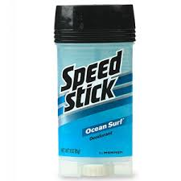](http://www.google.com/imgres?imgurl=http://pics2.ds-static.com/prodimg/26286/300.jpg&imgrefurl=http://www.drugstore.com/speed-stick-by-mennen-deodorant-clear-solid-ocean-surf/qxp26286&h=300&w=300&sz=20&tbnid=oEU7_3vM_7IexM:&tbnh=85&tbnw=85&prev=/search?q=photo+of+deodorant&tbm=isch&tbo=u&zoom=1&q=photo+of+deodorant&usg=__lNfj0WpZ4y3wrDXzNUdPkBwCg4M=&docid=mNXshlsjHr0wzM&sa=X&ei=oVXMUYnuCKb64APmiICICQ&ved=0CEIQ9QEwBw&dur=1708)[](http://www.google.com/imgres?q=photo+of+toilet+paper&biw=1920&bih=985&tbm=isch&tbnid=pYOeLf5DgHJEnM:&imgrefurl=http://www.wcti12.com/news/Truck-hauling-toilet-paper-goes-up-in-flames/-/13530444/14802312/-/63vt4e/-/index.html&docid=dXV6wnbolWrtNM&imgurl=http://www.wcti12.com/image/view/-/14802422/highRes/1/-/9t9pcz/-/0613-TP-fire-image.jpg&w=319&h=304&ei=UYDMUcX4Etbi4AOVzIGYDQ&zoom=1&ved=1t:3588,r:23,s:0,i:156&iact=rc&page=1&tbnh=180&tbnw=217&start=0&ndsp=42&tx=132&ty=79) [](http://www.google.com/imgres?q=photo+of+sanitary+napkins&biw=1920&bih=985&tbm=isch&tbnid=rYNQC1tK4WlGqM:&imgrefurl=http://www.pnsexplosion.com/2008/11/pns300-kotex-mex.html&docid=J_yItD0NXDDPdM&imgurl=http://pnsexplosion.com/uploaded_images/Kotex_Sanitary_Napkins-776965.jpg&w=767&h=633&ei=uIDMUaaaErbG4AOr_ICgDA&zoom=1&ved=1t:3588,r:96,s:0,i:375&iact=rc&page=3&tbnh=196&tbnw=237&start=83&ndsp=50&tx=72&ty=92)

* Special Items: contact lens cleaner, hearing aid batteries

[](http://www.google.com/imgres?imgurl=http://i.istockimg.com/file_thumbview_approve/157784/2/stock-photo-157784-contact-lens-case.jpg&imgrefurl=http://www.istockphoto.com/stock-photo-157784-contact-lens-case.php&h=285&w=380&sz=29&tbnid=lAU6tEuwHjH6MM:&tbnh=85&tbnw=113&prev=/search?q=photo+of+contact+lens+cases&tbm=isch&tbo=u&zoom=1&q=photo+of+contact+lens+cases&usg=__U6ZI_eVi0mhYjo8TABZfP_-8ju8=&docid=ryx8ecMLzfbcqM&sa=X&ei=-XXMUaXmA5G24AOR54CYDw&ved=0CIYBEPUBMBM) [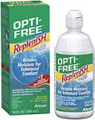](http://www.google.com/imgres?imgurl=http://i1.allaboutvision.com/i/alcon-opti-free-replenish-160x203.jpg&imgrefurl=http://www.allaboutvision.com/contacts/caresoftlens.htm&h=203&w=160&sz=22&tbnid=RyemxbE_i8TaGM:&tbnh=91&tbnw=72&prev=/search?q=photo+of+contact+lens+cleaner&tbm=isch&tbo=u&zoom=1&q=photo+of+contact+lens+cleaner&usg=__ypIbleyQ3Ii5RZAbpUZeXd4JChw=&docid=kYo8VFp7a9adcM&sa=X&ei=OXHMUdDiEff94APttoGgDw&ved=0CFMQ9QEwAw&dur=284) 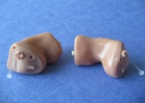[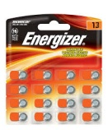](http://www.google.com/imgres?imgurl=http://c4.soap.com/images/products/p/egz/egz-039_1z.jpg&imgrefurl=http://www.soap.com/p/energizer-hearing-aid-batteries-size-13-58405&h=1498&w=1245&sz=212&tbnid=7H1I121HnzRX2M:&tbnh=90&tbnw=75&prev=/search?q=photo+of+hearing+aid+batteries&tbm=isch&tbo=u&zoom=1&q=photo+of+hearing+aid+batteries&usg=__G6nKcbQQKWKzEXcH4pXpFYQFL1A=&docid=gTN2_B_6W6SykM&sa=X&ei=ZXXMUdSyKdfl4AOL3oHADA&ved=0CJMBEPUBMBE)

* Board games, books to keep you busy [](http://www.google.com/imgres?q=photo+of+harry+potter+book+cover&biw=1920&bih=985&tbm=isch&tbnid=5RAMAqS-REsI5M:&imgrefurl=http://hotteahotbooks.wordpress.com/2011/08/28/yes-i-do-judge-books-by-their-covers/&docid=dUL5lYoB6KfvcM&imgurl=http://hotteahotbooks.files.wordpress.com/2011/08/51df6zr8g7l.jpeg&w=300&h=300&ei=33vMUc7cA-nl4AP9soGIAQ&zoom=1&ved=1t:3588,r:44,s:0,i:219&iact=rc&page=1&tbnh=202&tbnw=202&start=0&ndsp=53&tx=97&ty=83) [](http://www.google.com/imgres?imgurl=http://static.tvtropes.org/pmwiki/pub/images/GoldenAgeSuperman.jpg&imgrefurl=http://tvtropes.org/pmwiki/pmwiki.php/Main/TheGoldenAgeOfComicBooks&h=416&w=300&sz=50&tbnid=QooAhr_hdFmItM:&tbnh=86&tbnw=62&prev=/search?q=photo+of+comic+books&tbm=isch&tbo=u&zoom=1&q=photo+of+comic+books&usg=__G9TaZnErrlWwEKXY58xlJ_Xe-bg=&docid=0LJMHpzv6kbrBM&sa=X&ei=QHbMUf64CO2u4AP3loDgDg&ved=0CD4Q9QEwAw&dur=1291) 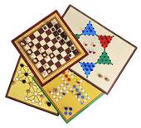
* First Aid Supplies: Bandages, Gauze, Tape, Alcohol [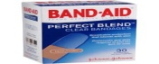](http://images.google.com/imgres?q=bandage&biw=1920&bih=985&tbm=isch&tbnid=pQuhd_AsUlSnBM:&imgrefurl=http://www.mountainside-medical.com/products/Band%252dAid-Clear-Bandage-Perfect-Blend-%252d-30-Count.html&docid=5YYKPQsLwKclFM&imgurl=http://www.mountainside-medical.com/product_images/uploaded_images/Band-Aid-Clear-Bandage-Perfect-Blend.jpg&w=300&h=300&ei=tHzdUYefLcPc4AOi5YEo&zoom=1&ved=1t:3588,r:87,s:0,i:356&iact=rc&page=3&tbnh=189&tbnw=189&start=80&ndsp=48&tx=100&ty=79)